**ELB-ASG-Route 53 Case Study**

**Problem Statement:**

You work for XYZ Corporation that uses on premise solutions and a limited number of systems. With the increase in requests in their application, the load also increases. So, to handle the load the corporation has to buy more systems almost on a regular basis. Realizing the need to cut down the expenses on systems, they decided to move their infrastructure to AWS.

**Tasks to Be Performed:**

1. Manage the scaling requirements of the company by:

a. Deploying the multiple compute resources on the cloud as soon as the load increases and the CPU utilization exceeds 80%

b. Removing the resources when the CPU utilization goes under 60%

2. Create a load balancer to distribute the load between compute resources.

3. Route the traffic to the company domain.

**Problem 1 (a) Solution:** Deploying the multiple compute resources on the cloud as soon as the load increases and the CPU utilization exceeds 80%

**A. Launch the Template for Creating Auto Scaling Groups**

**Step 1: Go** tothe **“Services”** section& **search** the **“EC2”** here**. Put** the **cursor** over **“EC2”** **&** **click** on the **“Dashboard”.**

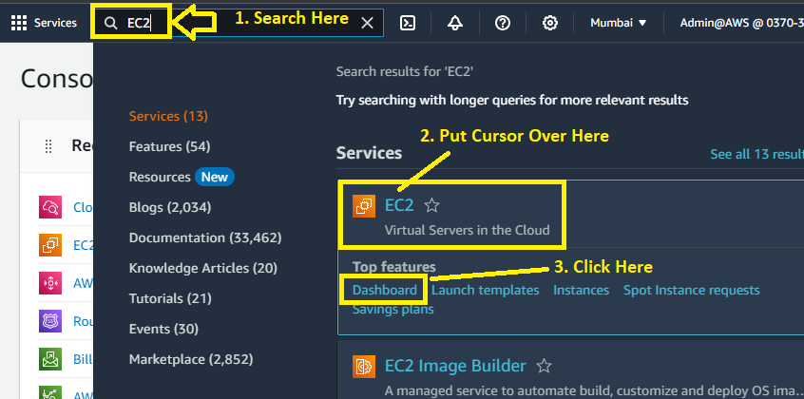

**Step 2: Go** tothe **“Instances>Launch Templates”.**

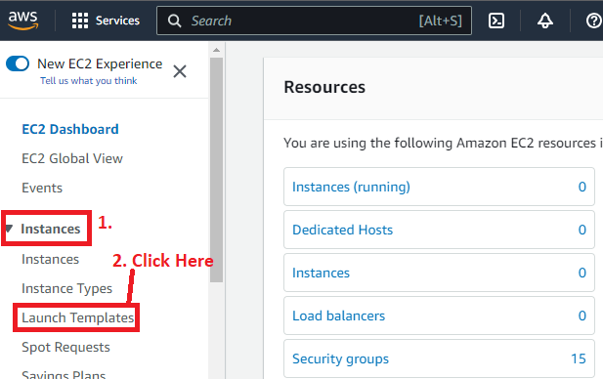

**Step 3: Click** onthe **“Create Launch Template”.**

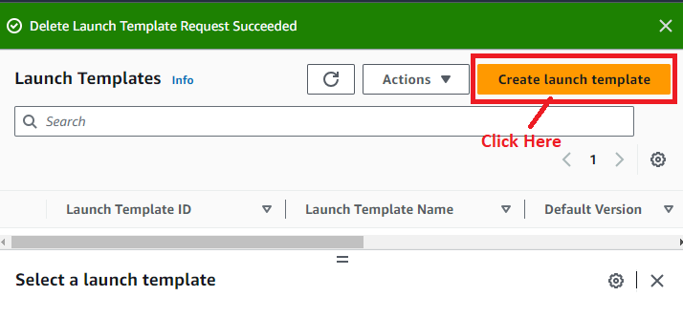

**Step 4: In** the **“Launch Template name and Description”, choose** the **following entries** over **here:**

**Launch template name – required:** DemoTemplateforASG

**Template version description:** A launch template for Auto Scaling Groups

***Enable Auto Scaling Guidance option, if you need any help.***

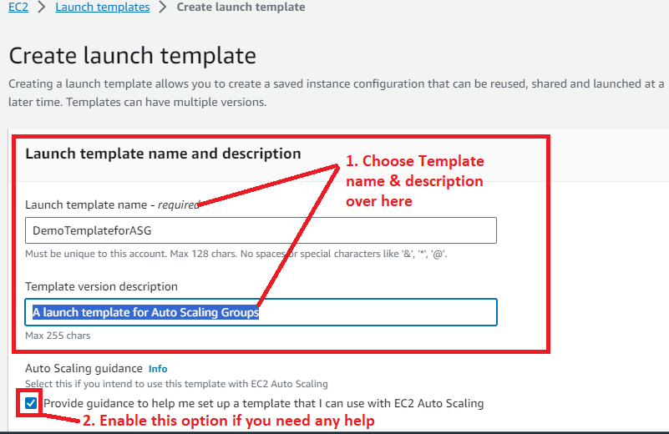

**Step 5:** Inthe **“Launch Template Contents”,** choosethe **“Quick Start”** option **in** the **“Application and OS Images (Amazon Machine Image) – required “. Choose “AMI”** as the **“Amazon Linux 2023 AMI”.**

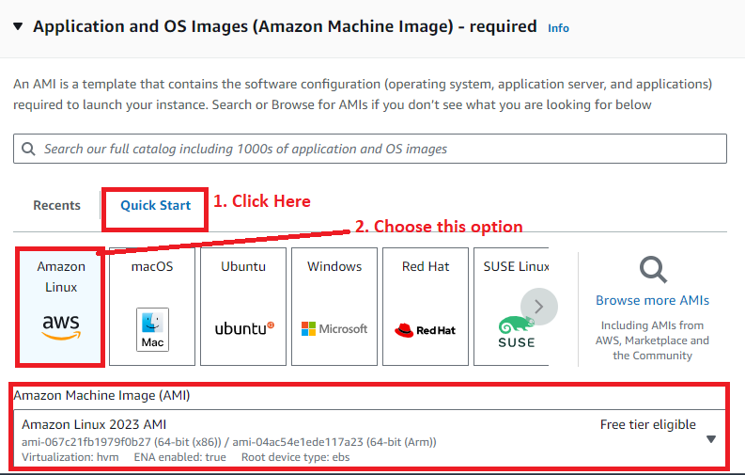

**Step 6: Choose** the **“Instance Type”** asthe **“t2.micro”.**

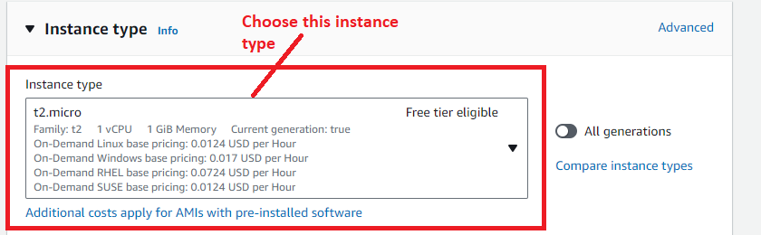

**Step 7: Choose** your **created key pair** here**. We** will **choose** the **“MY-WEB-SERVER”** asa **“key pair (login)”.**

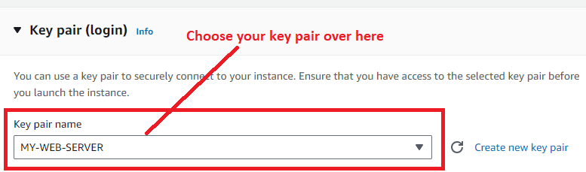

**Step 8: We** will not **include** the **“subnet”** over here**. In** the **“Auto scaling group”, we** havethe **subnet** option there**.**

**Choose** the **“Select existing security group”** in the **“Firewall (security groups)”. Also, choose** your **created security group (launch-wizard-6)** in the **“Security groups”.**

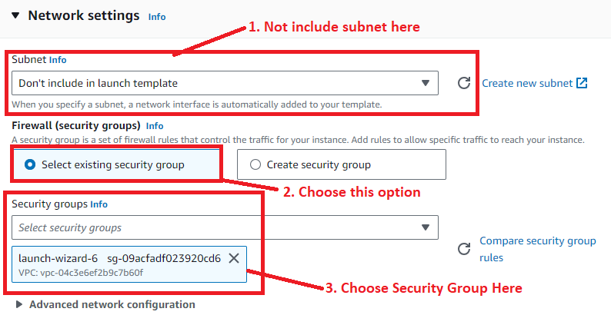

**Step 9: Go** to the **“Advanced Details”, paste** the **user data script** forthe **“apache 2 web server installation”.**

**#!/bin/bash**

**yum update -y**

**yum install -y httpd.x86_64**

**systemctl start httpd.service**

**systemctl enable httpd.service**

**echo "Hello World from $(hostname -f)" > /var/www/html/index.html**

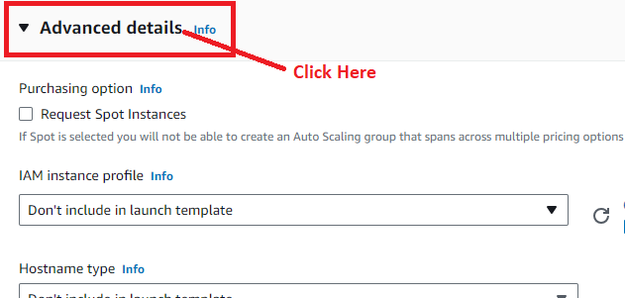

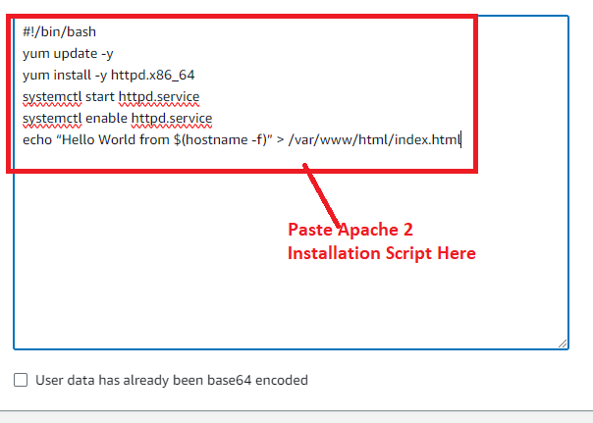

**Step 10: Click** onthe **“Create launch template”.**

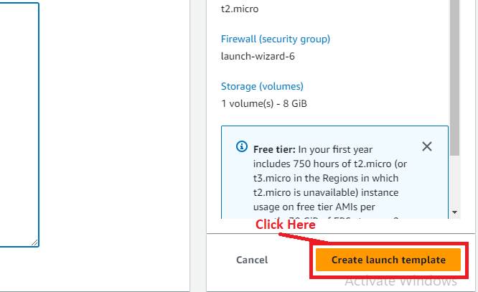

**Step 11: The launch template** will be **successfully created. Click** onthe **“Launch template hyperlink”.**

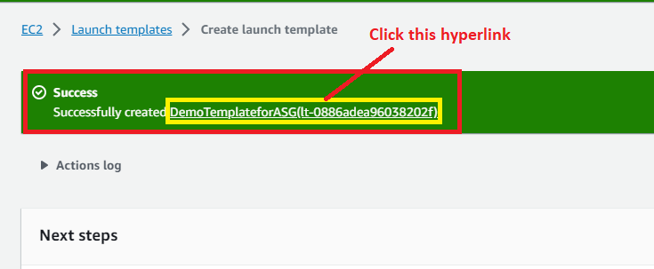

**Step 12: Your launch template details** will be **shown to you.**

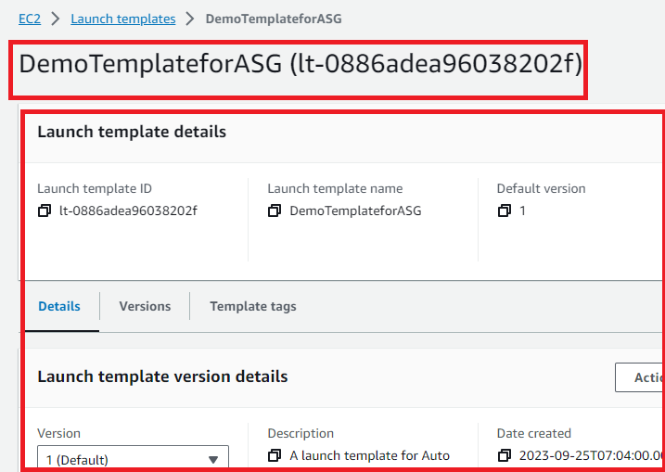

**B. Create an Auto Scaling Group Which Create Instances After 80% Exhaustion & Automatically Creates New Instances**

**Step 1: Go** tothe **“Auto Scaling > Auto Scaling Groups”.**

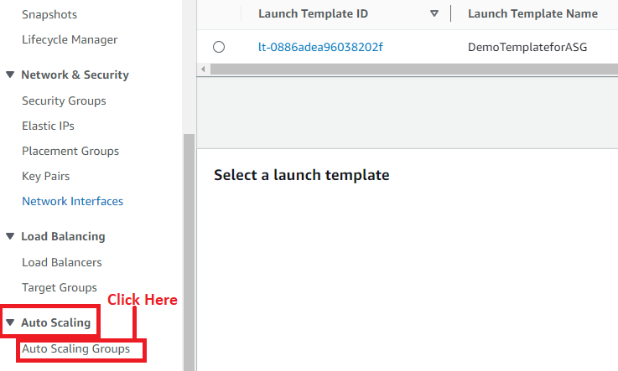

**Step 2: Click** onthe **“Create Auto Scaling group”.**

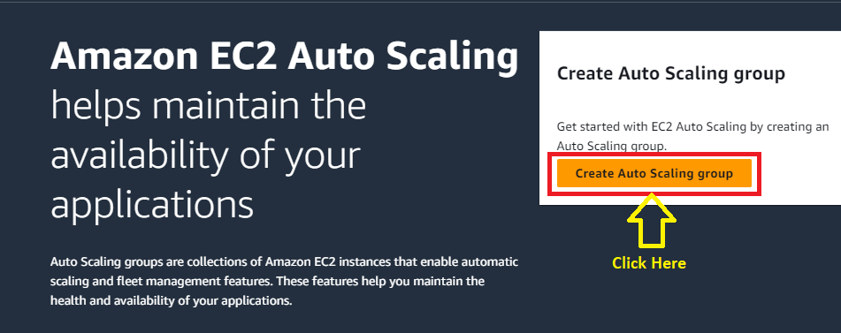

**Step 3: Choose** the **“Auto Scaling group name”** as **“MySecondAutoScalingGroup”.**

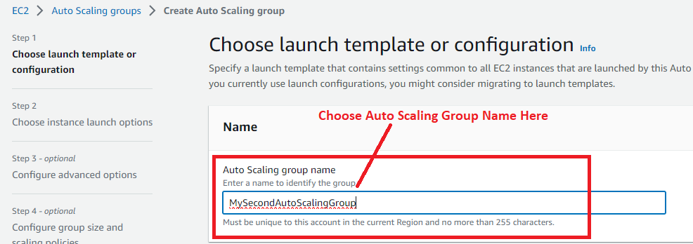

**Step 4: Choose** the **“Launch Template”** asthe **“DemoTemplateforASG”.**

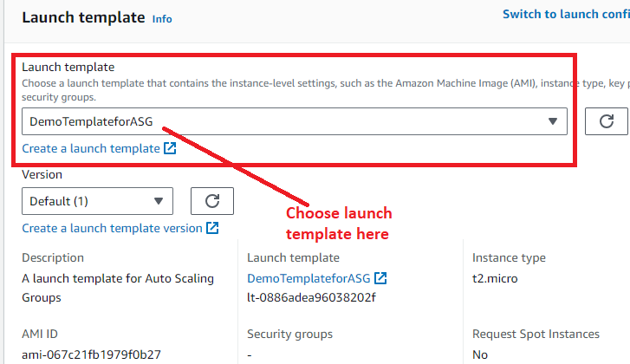

**Step 5: Click** onthe **“Next”.**

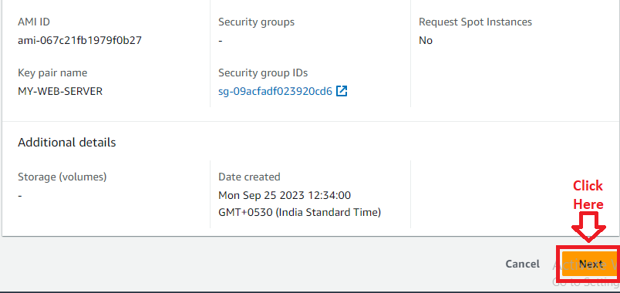

**Step 6: We** will **choose** the **“Availablility Zones”** as the **“ap-south-1a”** & **“ap-south-1b”**inthe **“Availability Zones and subnets”. (If you don’t have subnets, create two subnets in the different availability zones)**

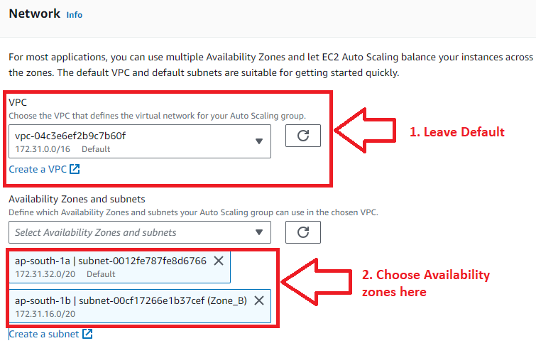

**Step 7: Click** onthe **“Next”.**

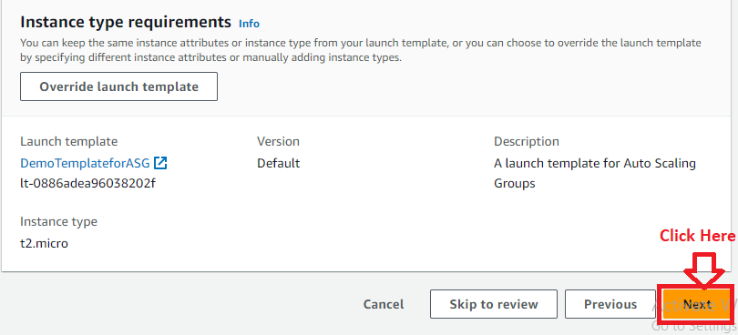

**Step 8: In** the **“Configure advanced options –optional”, choose** the **“No load balancer”** inthe **“Load balancing”** option.

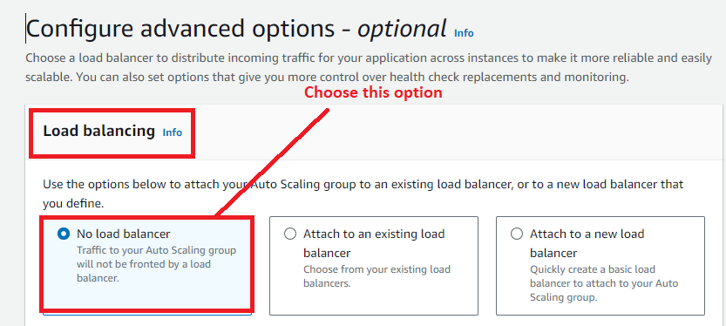

**Step 9: Click** onthe **“Next”** inthe **“Additional settings”.**

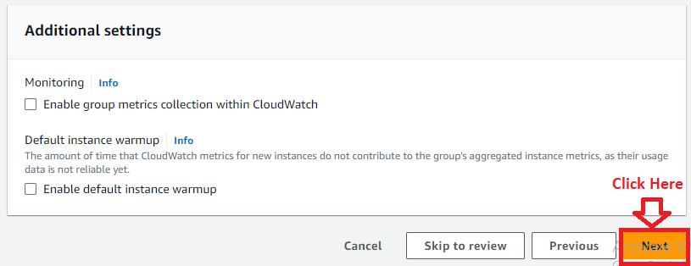

**Step 10: In** the **“Group size – optional”, choose** the **“Maximum Capacity”** as **“3”** & **leave** the **other capacity** as **it is.**

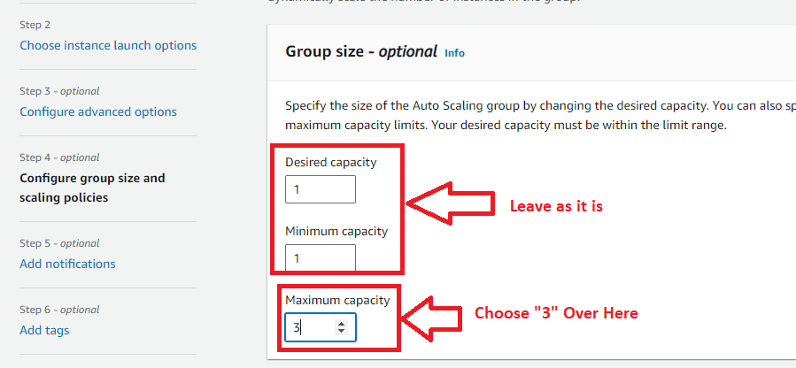

**Step 11: For now, select** the **“Scaling Policy”** as the **“None”.**

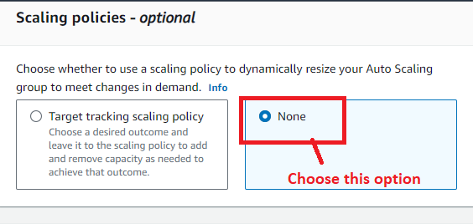

**Step 12: Select** the **“Enable instance scale-in protection”** & **click** onthe **“Next”.**

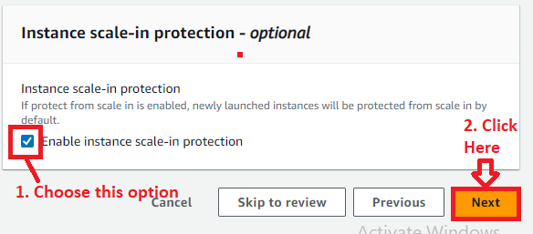

**Step 13: Click** onthe **“Next”** inthe **“Add notifications-optional”.**

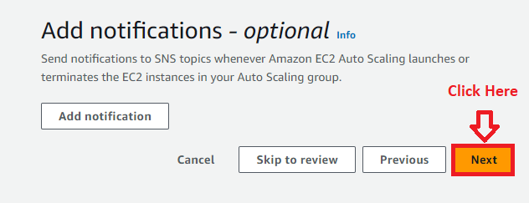

**Step 14: Click** onthe **“Next”** inthe **“Tags”** section**.**

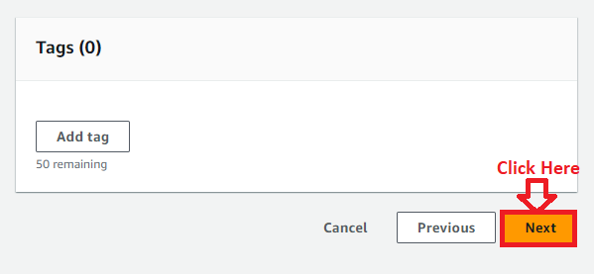

**Step 15: In** the **“Review”** section**, you** can **review** your **auto scaling group settings, if you want** to **do any change, you** can do **here. Otherwise, click** onthe **“Create Auto Scaling group”.**

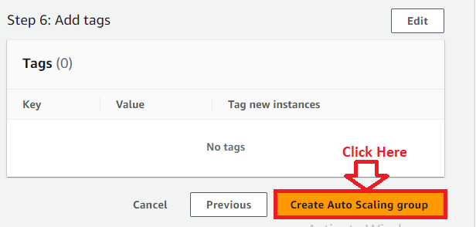

**Step 16: Your Auto Scaling Group “MySecondAutoScaling”** has been **successfully created.**

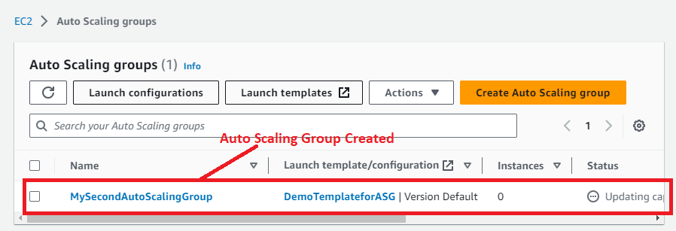

**Step 17: After clicking** on **your “Auto Scaling Group Name”, all** the **details** of the **group** will be **shown.**

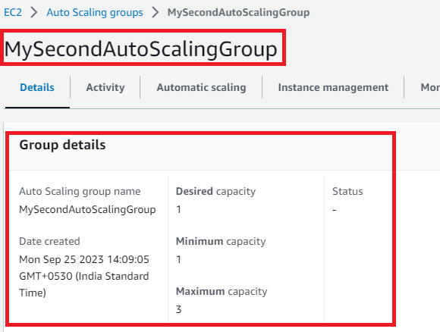

**Step 18: Go** to the **“Activity”** & **your “EC2 Instance”** will be **successfully launched.**

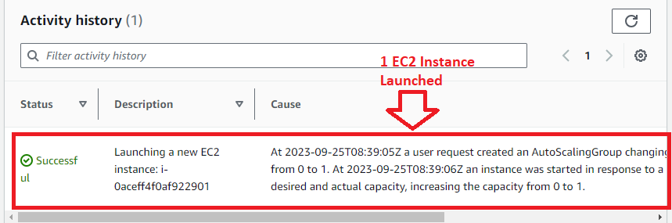

**C. Create First Dynamic Scaling Policy for Auto Scaling Group**

**Step 1: Go** to the **“Automatic Scaling”.**

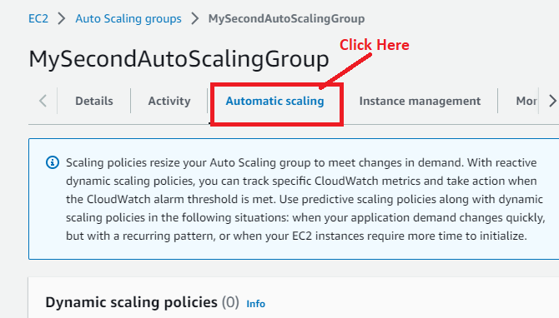

**Step 2: Click** on the **“Create dynamic scaling policy”.**

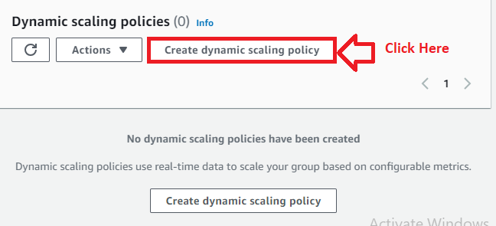

**Step 3: Choose** the **following options** over **here:**

**Policy type –** Simple Scaling

**Scaling policy name –** MyFirstPolicy

**CloudWatch Alarm –** Leave as it is, we will create the alarms after creating the policy.

**Take the Action –** Add as 1 capacity units.

**And then wait –** 120 seconds before allowing another activity.

**Click** on the **“Create”.**

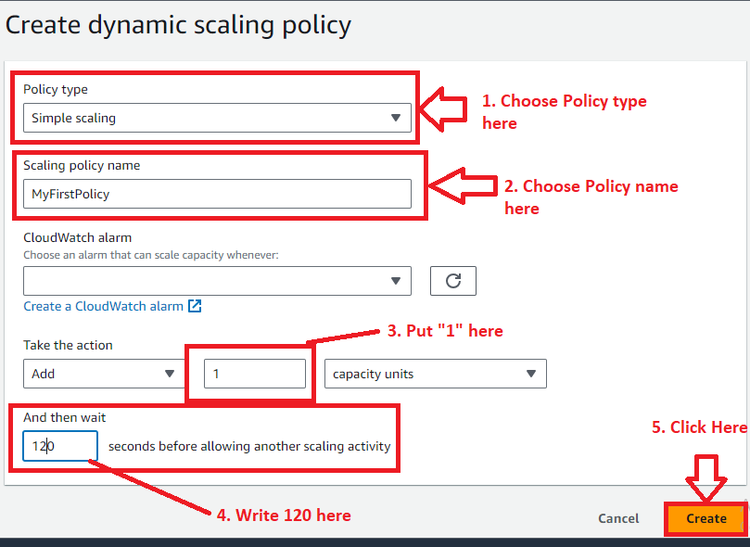

**Step 4: The Dynamic Policy** as **“MyFirstPolicy”** will be **successfully created.**

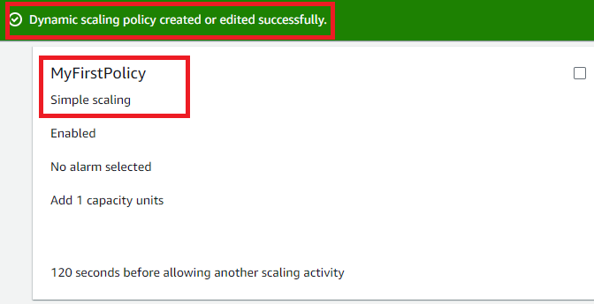

**D. Create the First Cloud Watch Alarm for Auto Scaling Group**

**Step 1: Go** tothe **“Services” section** & **search** the **“CloudWatch”** over **here. Put cursor** over **“CloudWatch”** & **click** on the **“Alarms”.**

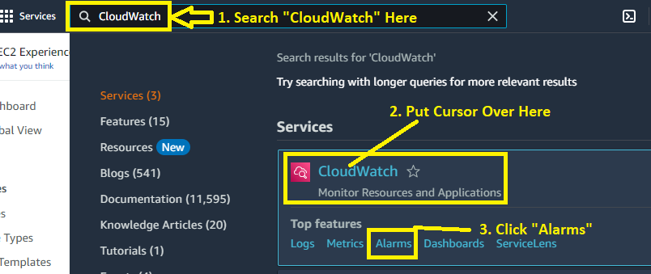

**Step 2: Click** on the **“Create alarm”.**

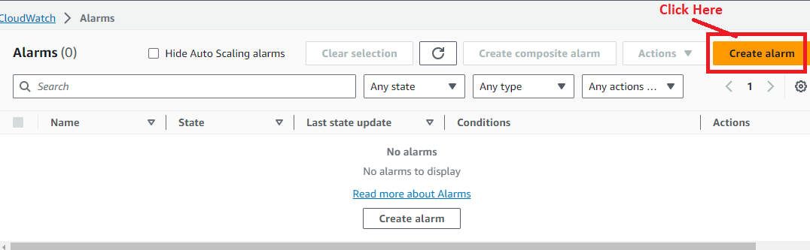

**Step 3: Click** onthe **“Select metric”.**

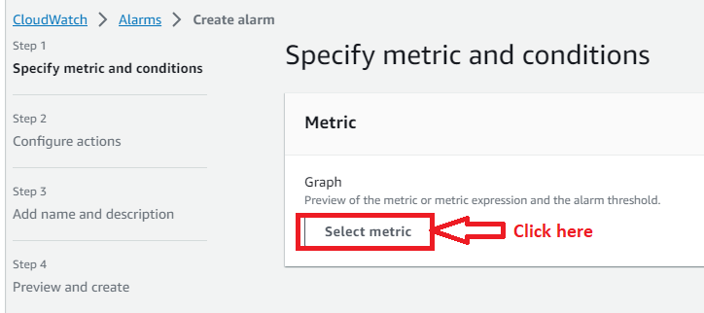

**Step 4: Click** on the **“EC2”** in **the “Metrics”** section.

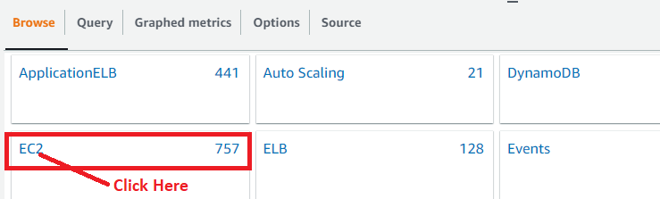

**Step 5: Click** onthe **“By Auto Scaling Group”.**

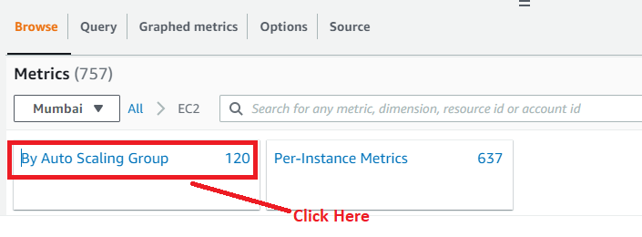

**Step 6: Choose** the **“MySecondAutoScalingGroup”** as the **“CPU Utilization” because we** have to **create another EC2 instance** after **80% CPU Utilization. Click** onthe **“Select metric”.**

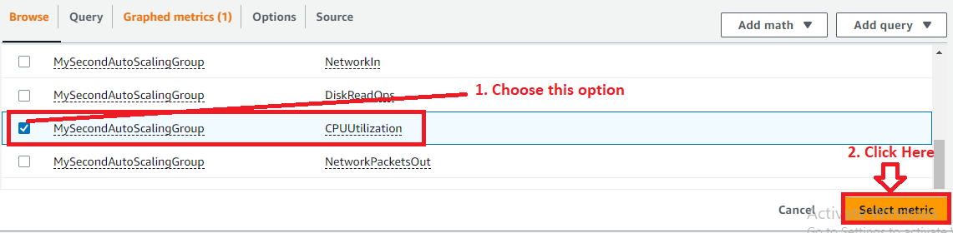

**Step 7: Leave** the **“Graph Settings”** as **it is.**

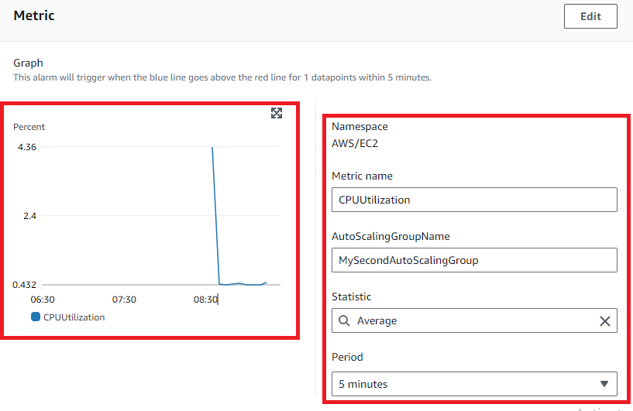

**Step 8: Leave** the **“Threshold type”** as **“static”** & **choose** the **“CPU Utilization”** is **greater** than **80%. Click** on the **“Next”.**

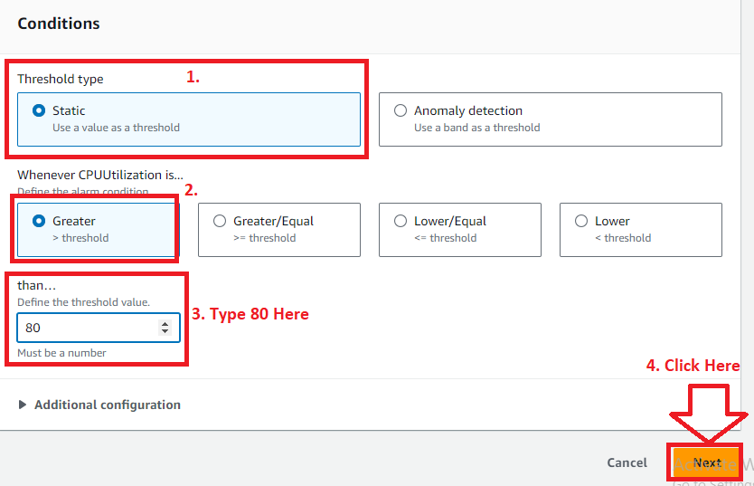

**Step 9: Go** tothe **“Notification”** & **click** on the **“Remove” because we** don’t **want** to **add notifications here.**

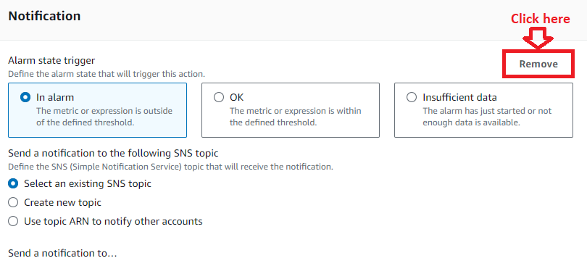

**Step 10: Click** onthe **“Add Auto Scaling action”.**

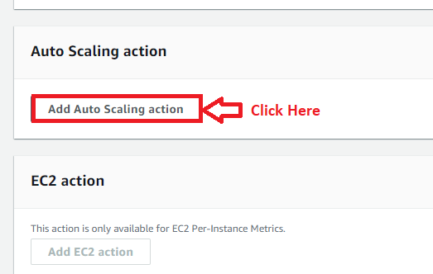

**Step 11: Choose the following options here:**

**Alarm state trigger –** In alarm

**Resource Type –** EC2 Auto Scaling group

**Select a group** – MySecondAutoScalingGroup

**Taking the following action..-** Automatically comes after choosing a group.

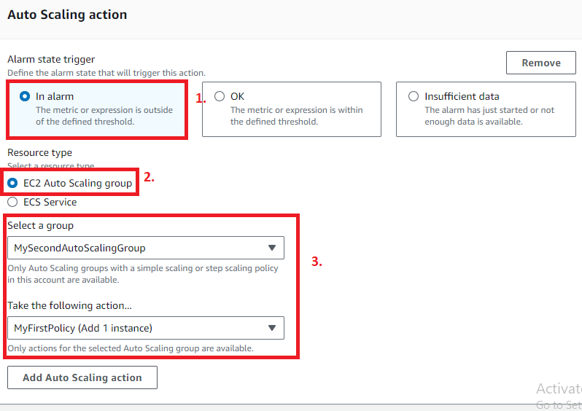

**Step 12: Click** on the **“Next”.**

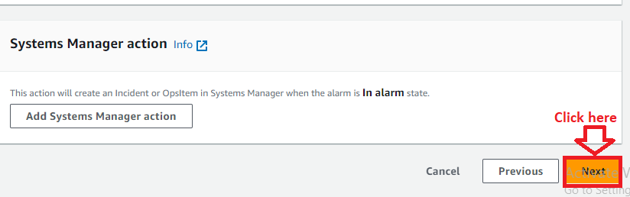

**Step 13: Choose** the **“Alarm Name”** as the **“CPUUtilization1ScalingGroup”. Click** onthe **“Next”.**

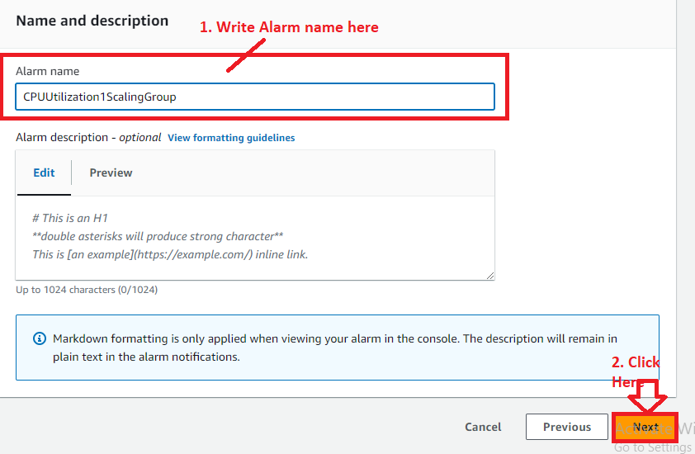

**Step 14: Click** on the **“Create alarm”** inthe **“Preview and create”** section**.**

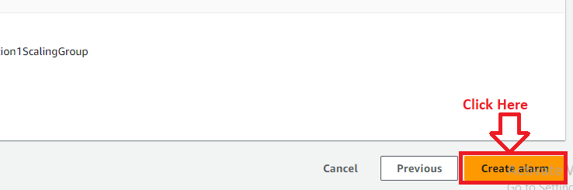

**Step 15: The alarm “CPUUtilization1ScalingGroup”** has been **successfully created. Click** onthe **Alarm Name** & **details** of **the alarm** will be **shown to you.**

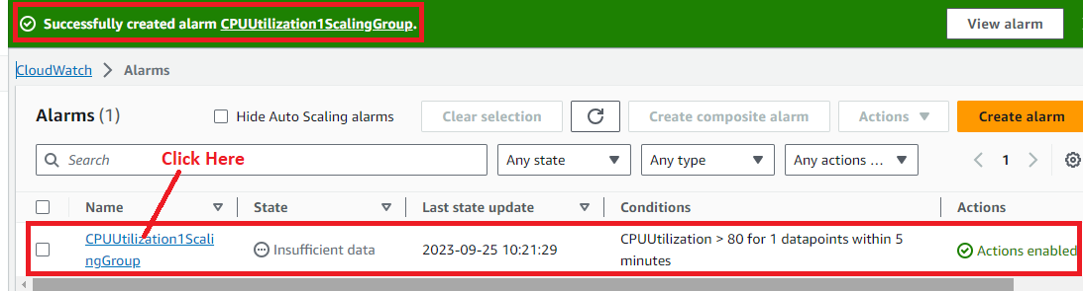

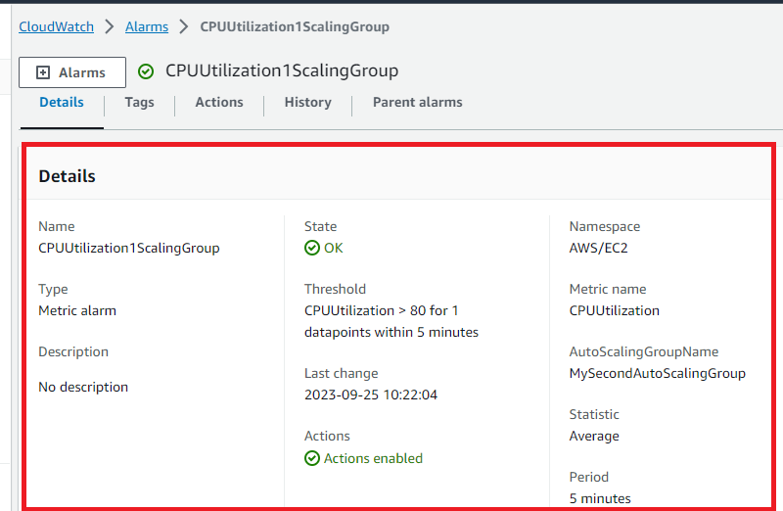

**Step 16: Go** tothe **“EC2” Services** & **click** onthe **“Dashboard”.**



**Step 17: Scroll down** inthe **left side menu bar** & **click** onthe **“Auto Scaling Groups”.**



**Step 18: Click** onthe **“MySecondAutoScalingGroup”.**

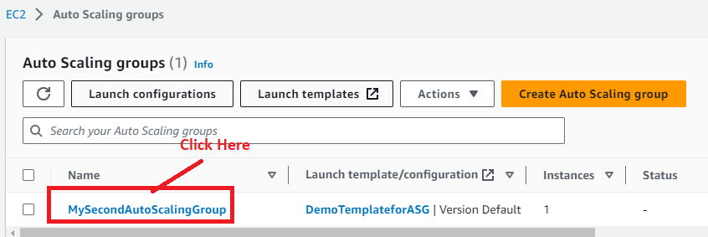

**Step 19: Go** tothe **“Automatic Scaling”.**



**Step 20: You** will **notice** that **“CPU Utilization” automatically added** in the **“MyFirstPolicy”.**

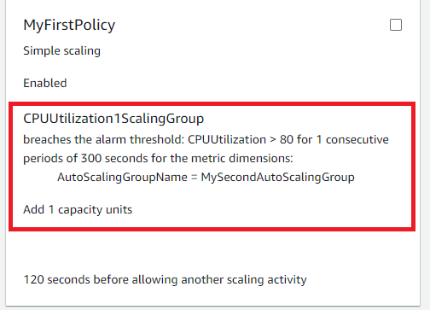

**E. Perform Testing on EC2 and Do CPU Utilization above 80% & Also Check EC2 Auto Scaling Group Adds Other Instance or Not**

**Step 1: Go** to the **“EC2 Dashboard”.**

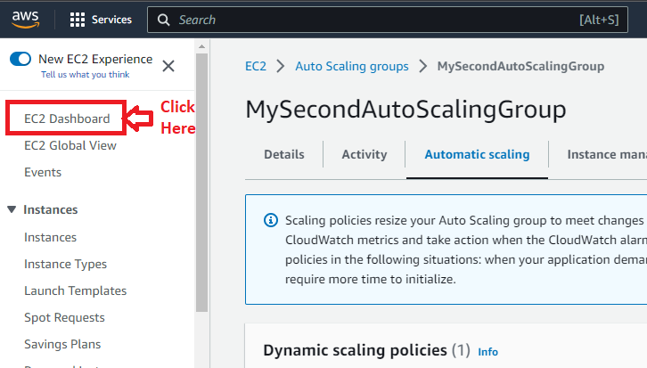

**Step 2: Click** on the **“Instances (running)”.**

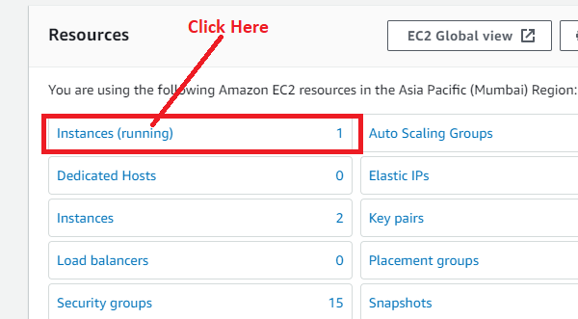

**Step 3: Select** the **Instance** & **click** on the **“Connect”.**

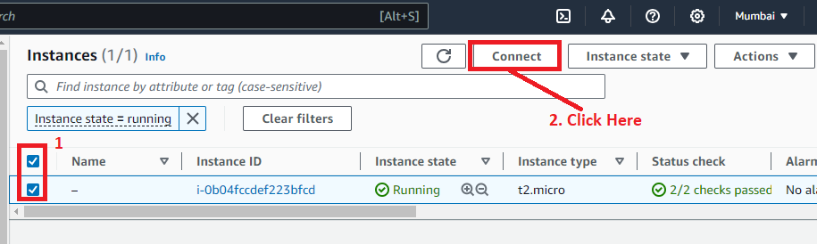

**Step 4: Click** on the **“Connect”** in the **“EC2 Instance Connect”.**

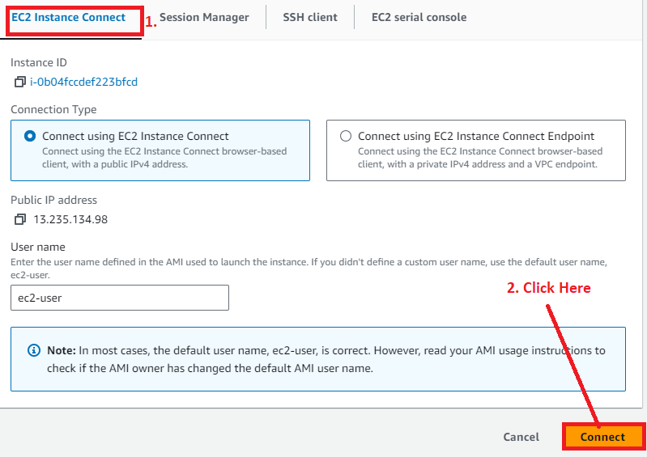

**Step 5: Your instance** will be **successfully opened.**

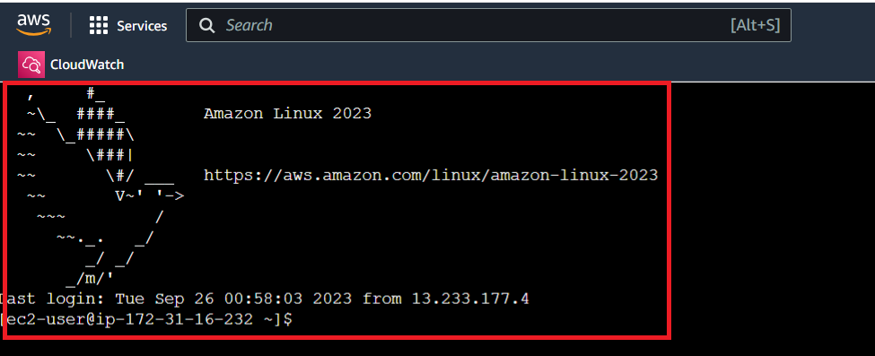

**Step 6: First, we** will **run** the **stress command** over **here.**

**sudo yum install stress -y**

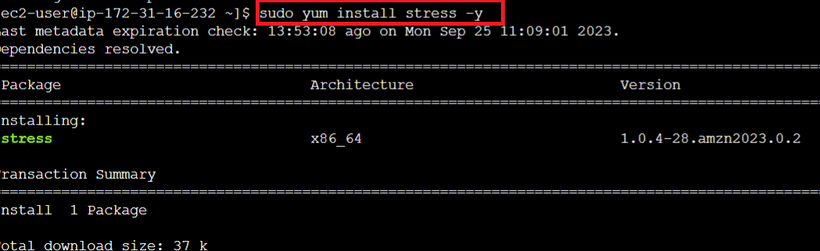

**Step 7: Now, we** will **run** the **CPU stress command & wait** until **5 minutes.**

**sudo stress --cpu 8 --vm-bytes $(awk '/MemAvailable/{printf "%d\n", $2 * 0.9;}' < /proc/meminfo)k --vm-keep -m 1**

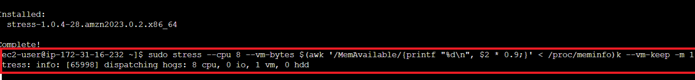

**Step 8: Now, go** tothe **instances** & **it** has **launched two other instances also. You** can **select** the **instance** to **check** the **“CPU Utilization”.**

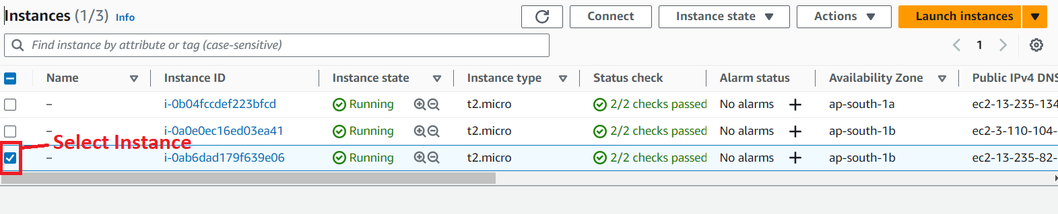

**Step 9: Go** to the **“Monitoring” & click** on the **three dots** in the **“CPU Utilization”.**

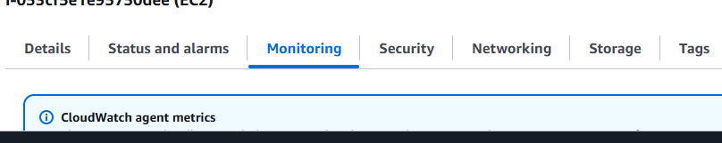

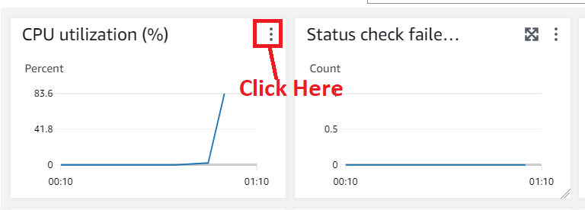

**Step 10: Click** on the **“Enlarge”.**

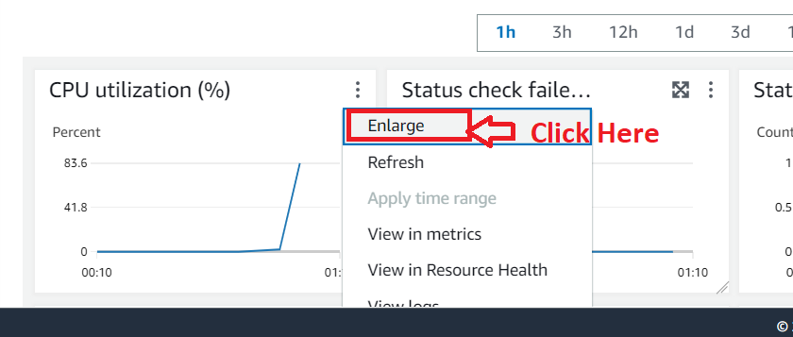

**Step 11: You** will **notice** that **your utilization** goes over **80%.**

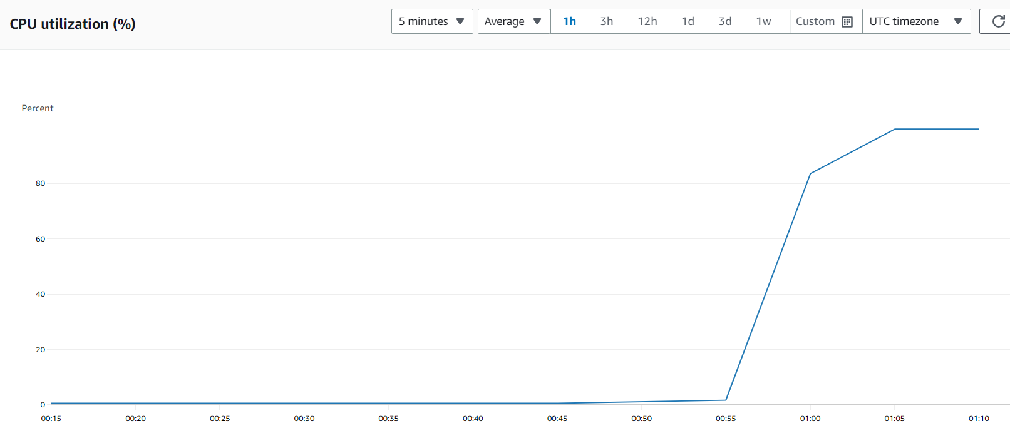

**Step 12: Go** tothe **“Services” section** & **search** the **“CloudWatch” here. Put** the **cursor** over **“CloudWatch” & click** on the **“Alarms”.**

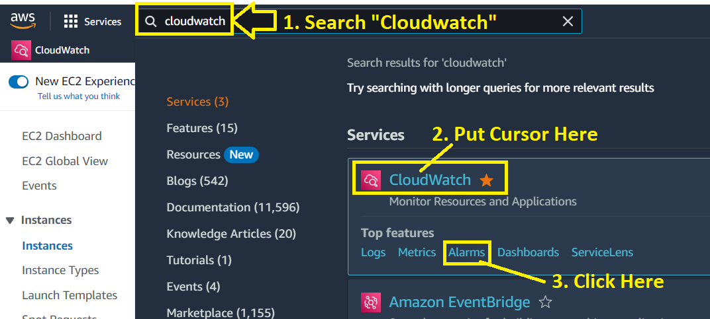

**Step 13: Your “CPU Utilization” shows** that **you** have **utilized CPU** over **80%** within **5 minutes** & **goes** to the **“In Alarm” state.**

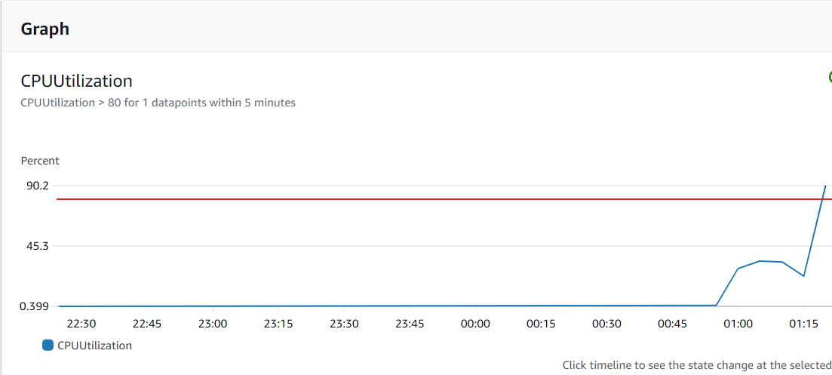

**Step 14: After utilizing** over **80%, it** will be **launched** the **two new instances. You** can **check** at **the “History”** section.

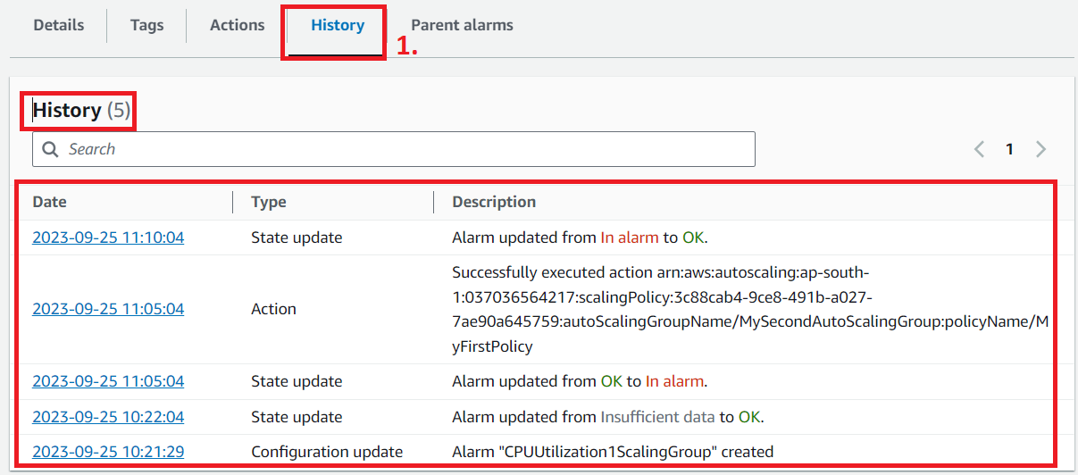

**Step 15: Go** tothe **“Services” section** & **search** the **“EC2”. Put cursor** overthe **“EC2” & click** onthe **“Dashboard”.**

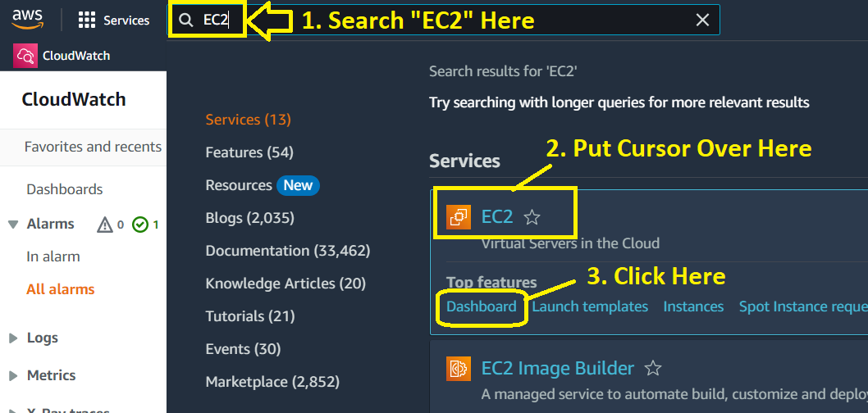

**Step 16: Click** onthe **“Auto Scaling Groups”.**

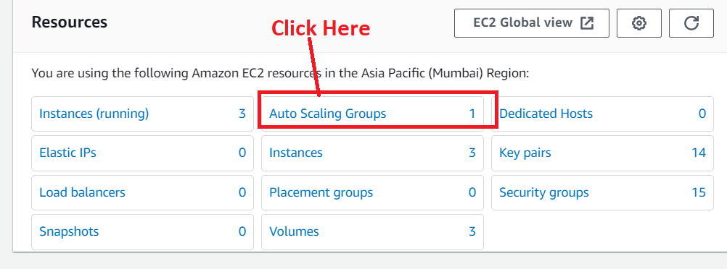

**Step 17: Click** on the **“Auto Scaling Group Name”.**

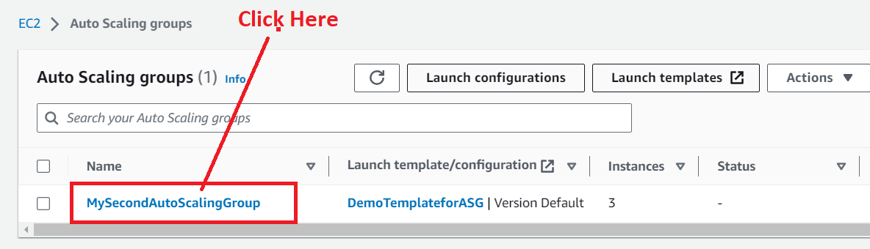

**Step 18: Go** tothe **“Activity”.**

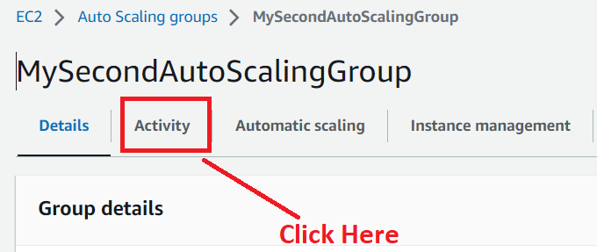

**Step 19: You** will **notice** the **two new instances launched** successfully.

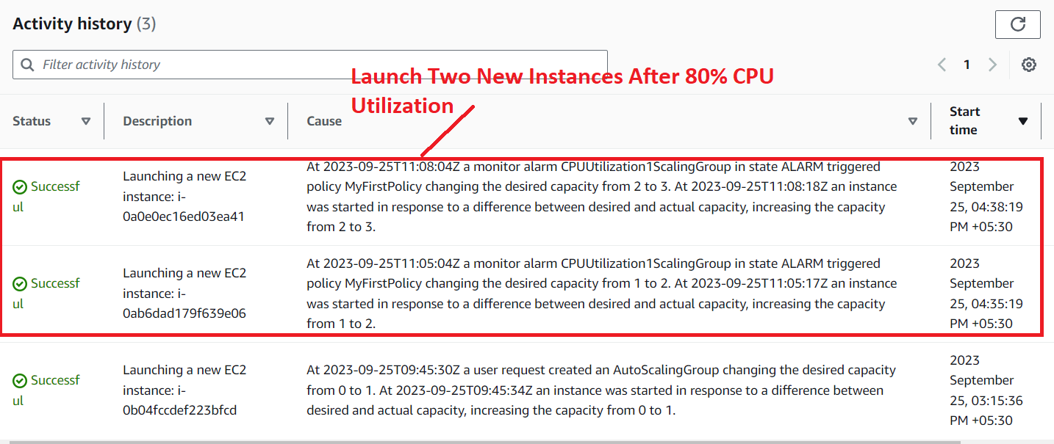

**Step 20: Go** tothe **“Details”. Now,** the **desired capacity** has been **increased** from **1 to 3** after **launching** the **two instances.**

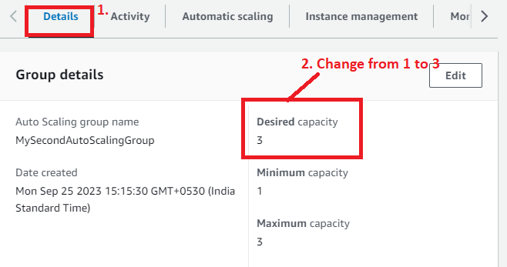

**So, this** is **the complete solution** after **utilizing** the **80% CPU, deploy** the **multiple resources through** the **Auto Scaling Groups.**

**Problem 1(b) Solution:** Removing the resources when the CPU utilization goes under 60%

**A. Create a Second Dynamic Scaling Policy for the Auto Scaling Group**

**Step 1: Go** to the **“Automatic Scaling”.**

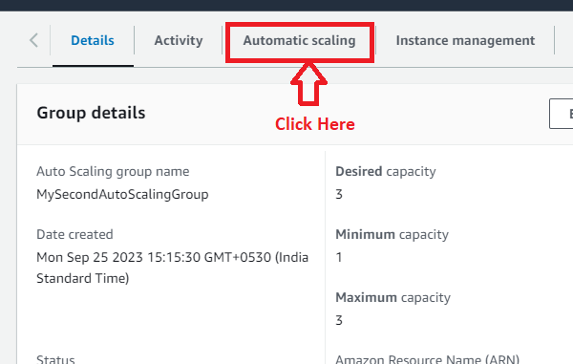

**Step 2: Click** on the **“Create dynamic scaling policy”.**

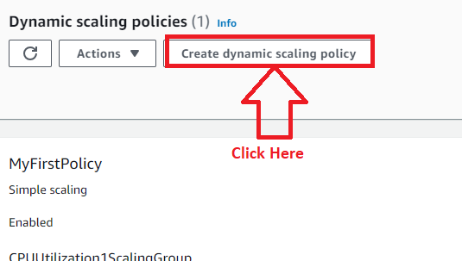

**Step 3: Choose the following option here;**

**Policy type –** Simple Scaling

**Scaling policy name** – MySecondPolicy

**Cloudwatch Alarm** – Creating After policy generated.

**Take the Action –** Remove – 1 –capacity units

**And then wait** – 120 seconds

**Click** on **“Create”.**

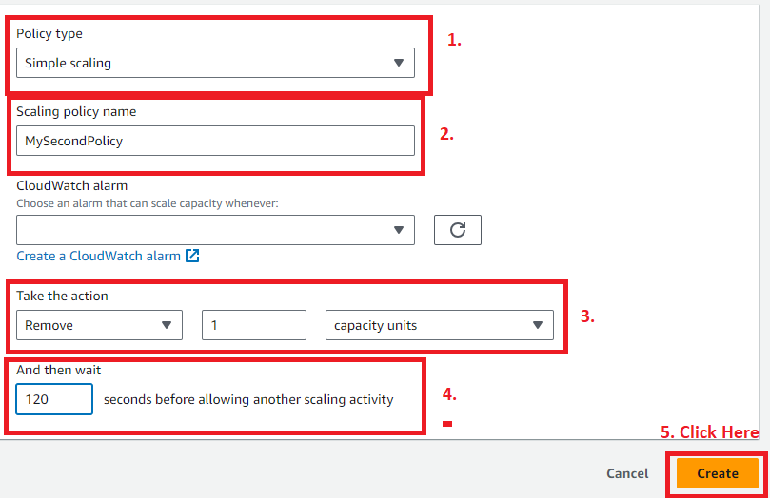

**Step 4:** The “**Second Dynamic Scaling policy”** will be **successfully created.**

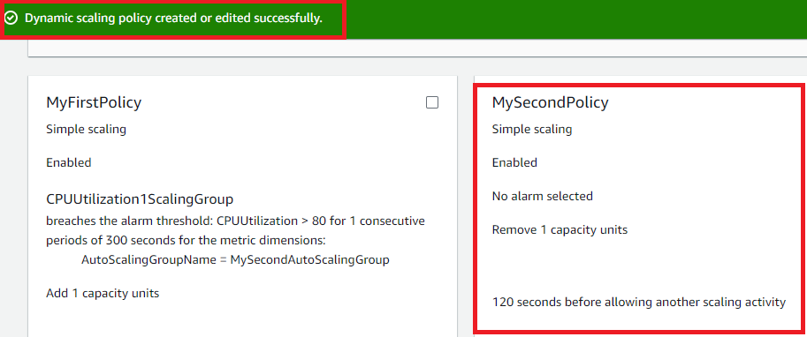

**B. Create the Second Cloud Watch Alarm for Auto Scaling Group**

**Step 1: Go** to the **“Services”** section & **search** the **“CloudWatch”. Put** the **cursor** over **“CloudWatch”** & **Click** on the **“Alarms”.**

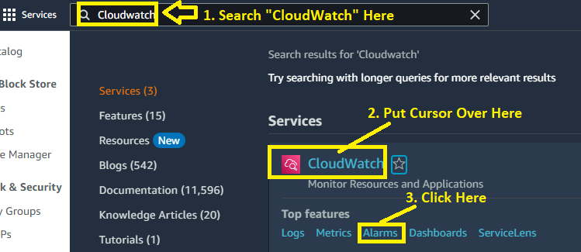

**Step 2: Click** onthe **“Create alarm”.**

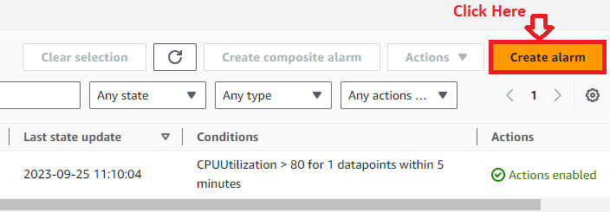

**Step 3: Click** onthe **“Select metric”.**

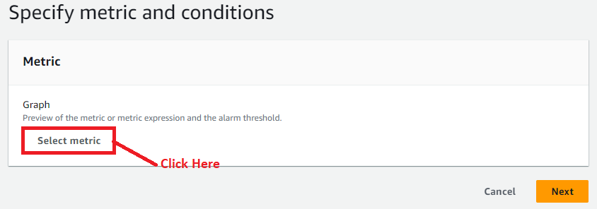

**Step 4: Click** on the **“EC2”** inthe **“Metrics”.**



**Step 5: Click** on the **“By Auto Scaling Group”.**



**Step 6: Choose** the **“MySecondAutoScalingGroup”** as the **“CPU Utilization” because we** have to **create another EC2 instance** after **80% CPU Utilization. Click** onthe **“Select metric”.**



**Step 7: Leave** the **“Graph Settings”** as **it is.**



**Step 8: Choose** the **“CPU Utilization”** as **“Lower/Equal”** than **“60%”. Click** on the **“Next”.**

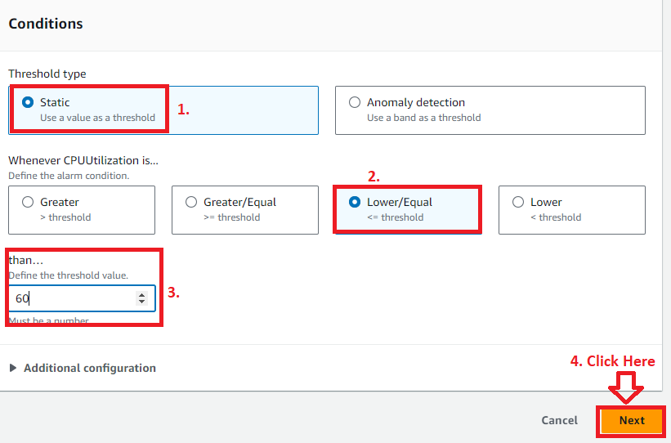

**Step 9: Go** tothe **“Notification”** & **click** on the **“Remove” because we** don’t **want** to **add** the **notifications here.**



**Step 10: Click** on the **“Add Auto Scaling action”.**



**Step 11: Choose the following options here:**

**Alarm state trigger –** In alarm

**Resource Type –** EC2 Auto Scaling group

**Select a group** – MySecondAutoScalingGroup

**Taking the following action -** Automatically comes after choosing a group.

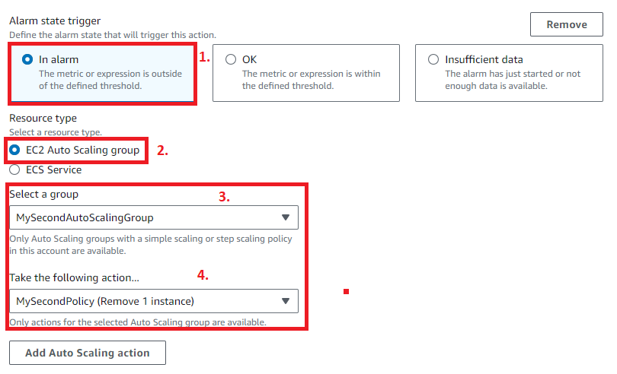

**Step 12: Click** on the **“Next”.**



**Step 13: Choose** the **“Alarm Name”** asthe **“CPUUtilization2ScalingGroup”. Click** onthe **“Next”.**

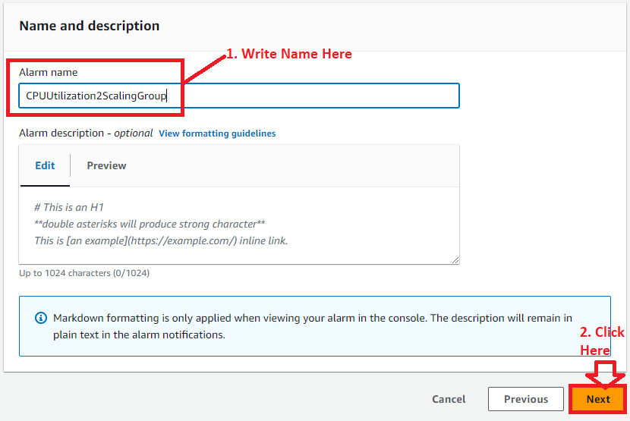

**Step 14: Click** on the **“Create alarm”** in the **“Preview and create”** section**.**



**Step 15: The alarm “CPUUtilization2ScalingGroup”** has been **successfully created. Click** on the **Alarm Name &** the **details** of the **alarm** will be **shown to you.**

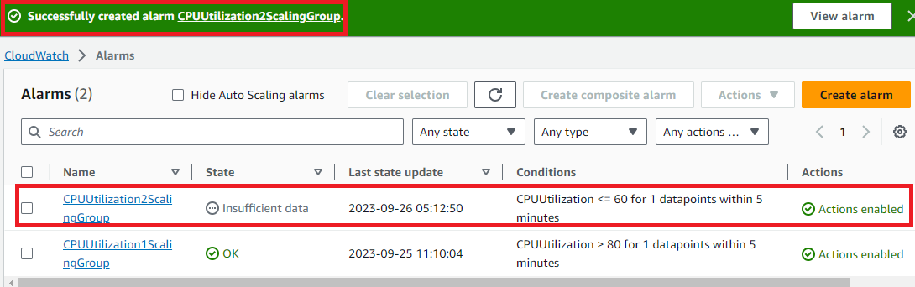

**Step 16: Go** to the **“EC2” Services** & **click** onthe **“Dashboard”.**



**Step 17: Scroll down** inthe **left side menu bar** & **click** on the **“Auto Scaling Groups”.**



**Step 18: Click** onthe **“MySecondAutoScalingGroup”.**



**Step 19: Go** tothe **“Automatic Scaling”.**



**Step 20: You** will **notice** thatthe **“CPU Utilization” automatically added** inthe **“MySecondPolicy”.**

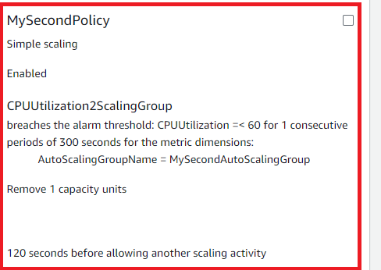

**C. Now Check the EC2 Auto Scaling Group & It Automatically Removed the Instance or Not**

**Step 1: Go** to the **“EC2” Services** & **click** on the **“Dashboard”.**



**Step 2: Scroll down** inthe **left side menu bar** & **click** on the **“Auto Scaling Groups”.**



**Step 3: Click** on the **“MySecondAutoScalingGroup”.**



**Step 4: Go** to the **“Activity”. After some time, it** will **terminate** the **two instances** because **“Minimum Instance limit”** is **“1”.**

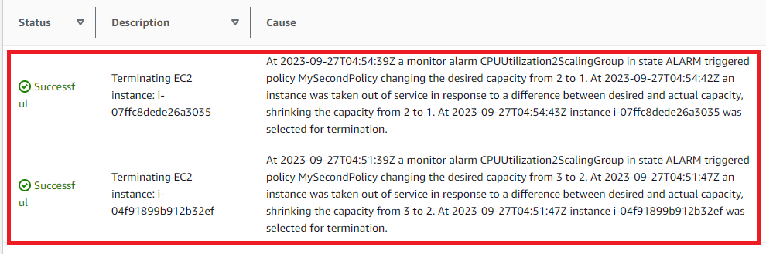

**Step 5: Now, go** tothe **“Details”** & **you** will **notice** thatthe **“Desired Capacity”** will be **reduced** from **“3”** to **“1”.**

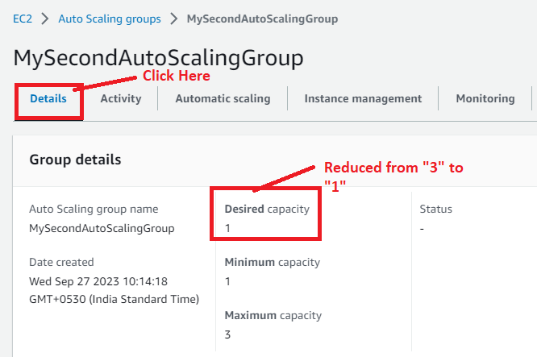

**Step 6: Now, click** on the **“EC2 Dashboard”** & **go** to the **“Instances (running)”.**

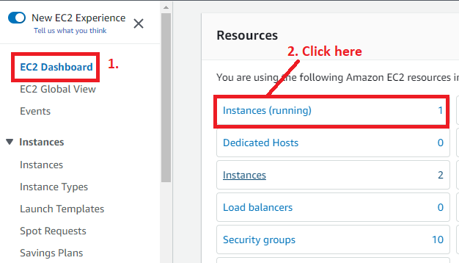

**Step 7: Now, only one instance** has been **shown** & **other instances** will be **terminated** & **removed out** from the **“EC2 Dashboard”.**

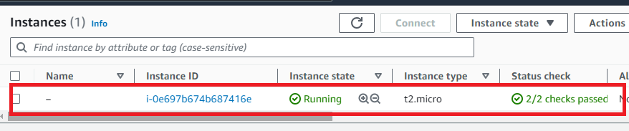

**Step 8: You** can **also check that** the **“instance** is **terminated”** from the **“CloudWatch” also. Go** to the **“Services”** section & **search** the **“CloudWatch”. Put the cursor** over the **“CloudWatch”** & **Click** onthe **“Alarms”.**



**Step 9: Your second alarm** will be **in** the **“In Alarm” state. Click** on the **“Alarm Hyperlink” (CPUUtilization2ScalingGroup).**

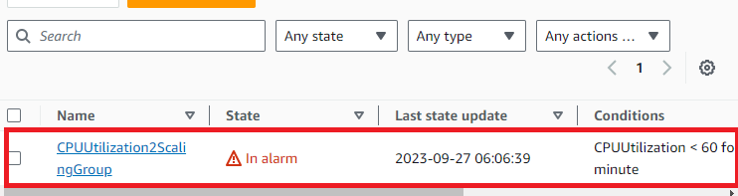

**Step 10: Your Alarm** will be **shown** in the **“In Alarm”** State**. Go** tothe **“History”** & **it** will **show you** that thes **“Scaling Policy”** is **executed.**

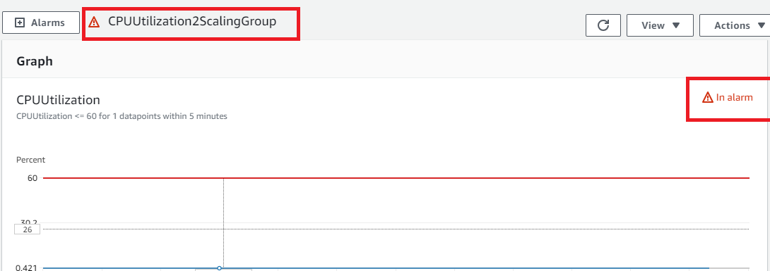

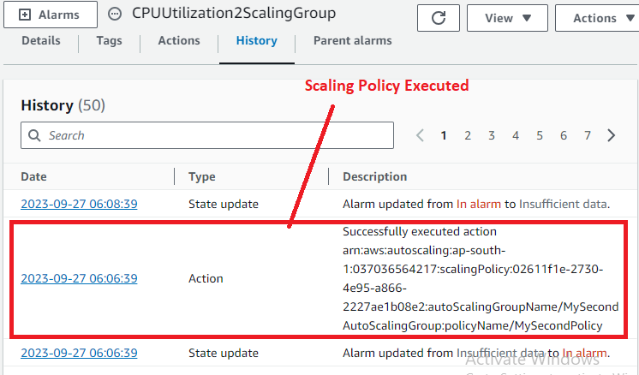

***Note: It is terminated two instances because we have set the minimum limit of “1 Instance” & Added the two instances because we have set the maximum limit of “3 Instance”. It launches two more instances to complete the maximum limit.***

***If we increase the load after applying both dynamic policy, Automatic Scaling works according to the policy, the instance will be created but second policy terminate that instance immediately, if there is not load on newly created instance. It is of because “Minimum 1 Instance Limit”.***

**So, this** is **the complete solution** after **utilizing** the **CPU** below **60%, remove** the **resources** through **Auto Scaling Groups.**

**Problem (2) Solution: Create a load balancer to distribute the load between compute resources.**

**A. Increase the Instance Limit in Automatic Scaling Group Because of Load Balancer Creation**

**Step 1: Go** to the **“Services”** section& **search** the **“EC2”** here**. Put** the **cursor** overthe **“EC2”** **&** **click** on the **“Dashboard”.**



**Step 2: Scroll down** in the **left side menu bar** & **click** onthe **“Auto Scaling Groups”.**



**Step 3: Click** on the **“MySecondAutoScalingGroup”.**



**Step 4: Go** tothe **“Details”** &your **instance “minimum and maximum capacity” shown** with the **“desired capacity”.**



**Step 5: Click** onthe **“Edit”.**

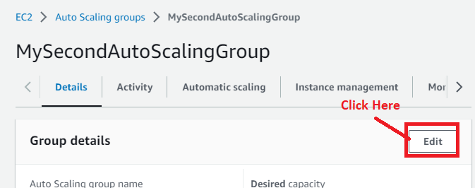

**Step 6: Choose** the **“Desired** & **Minimum Capacity”** as **“2”. Click** onthe **“Update”.**

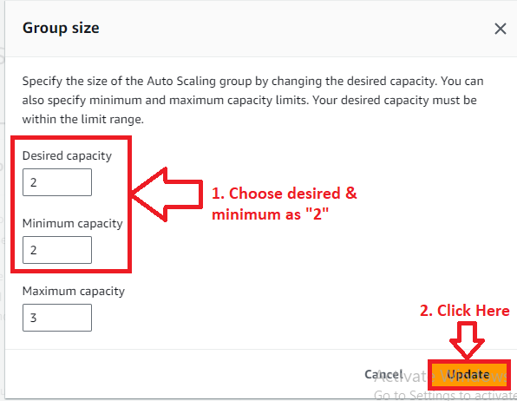

**Step 7: It** will **launch** the **another instance. And,** the **dynamic scaling policy** will not **remove** this **instance because minimum** & **maximum capacity** is **now “2”.**

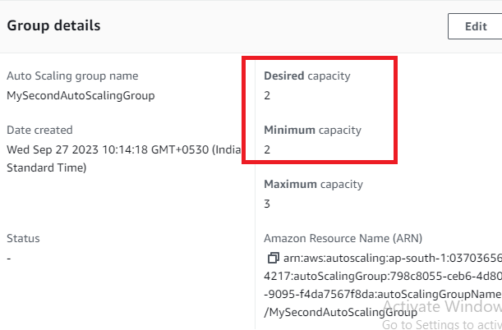

**Step 8: Go** tothe **“Activity”** & **Automatic Scaling group** will **launch** the **other instance automatically. Now,** the **two instances** will be **live.**

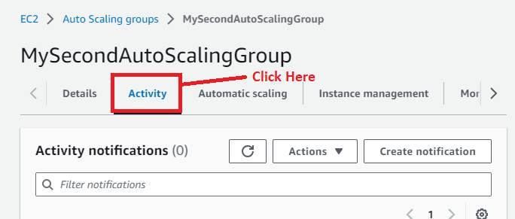

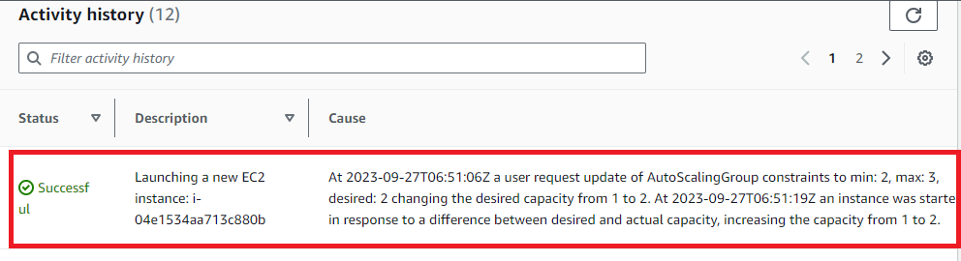

**Step 9: Go** tothe **“Services”** section& **search** the **“EC2”** here**. Put** the **cursor** over the **“EC2”** **&** **click** on the **“Dashboard”.**



**Step 10: Now, click** on the **“EC2 Dashboard”** & **go** to the **“Instances (running)”.**

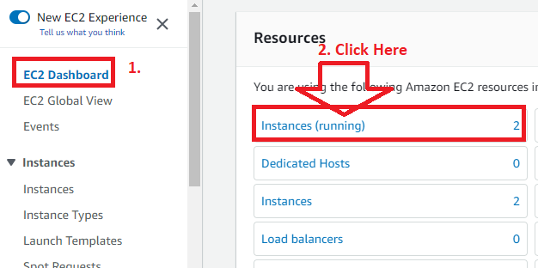

**Step 11: Your two instances** will be **showing** in the **“Running”** state**.**

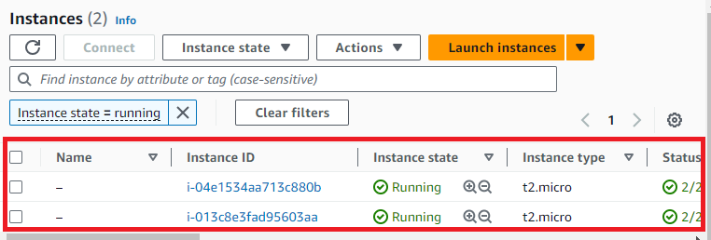

**Step 12: Select the “First Instance (i-04e1534aa713c880b). Click on “Open Address”.**

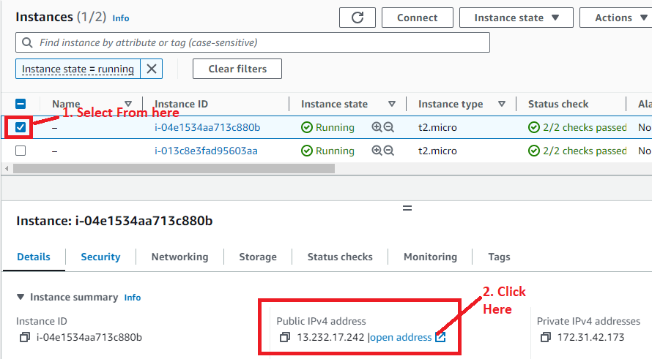

**Step 13: A Web page** will be **opened, where Apache web server** has been **installed.**

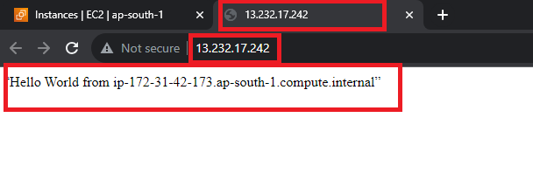

**Step 14: Select** the **“Second Instance (i-0013c8e3fad95603aa). Click** on the **“Open Address”.**

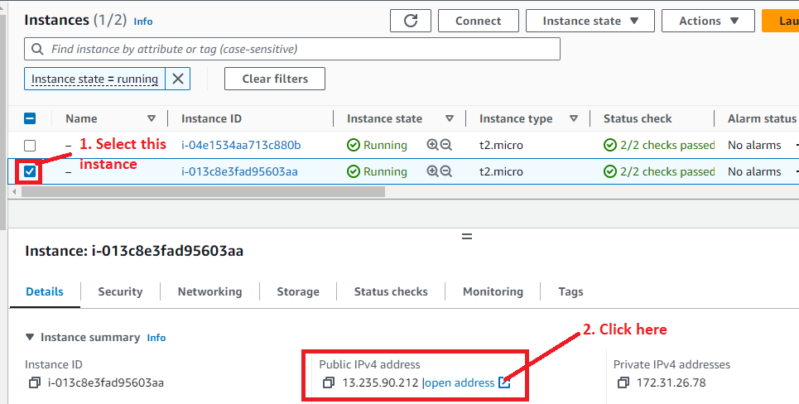

**Step 15: A Web page** will be **opened, where Apache web server** has been **installed.**

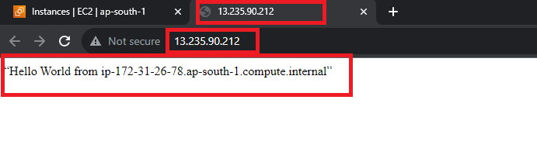

**B. Create a Target Group for Application Load Balancer**

**Step 1: In** the **left side** of the “**EC2”, scroll down. Click** on the **“Target Groups”** in the **“Load Balancing”.**

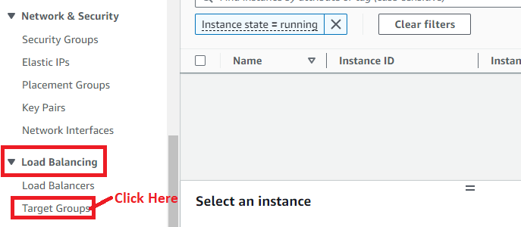

**Step 2: Click** onthe **“Create target group”.**

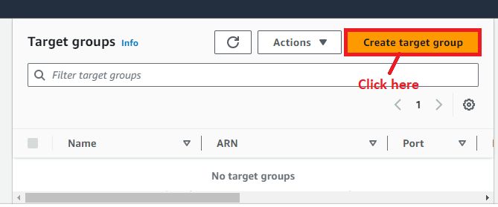

**Step 3: “Choose** a **target type”** asthe **“Instances”.**

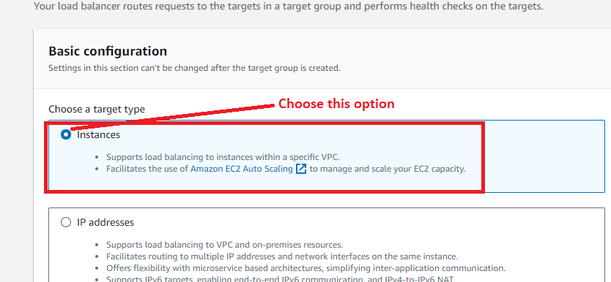

**Step 4: Choose** the **“Target Group Name”** as **“EC2AutoScalingTargetGroup”.**

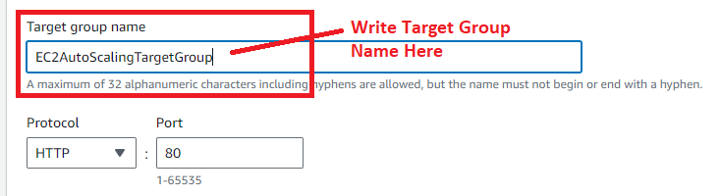

**Step 5: Leave** the **“HTTP Protocol” & “VPC Settings”** as **it is.**

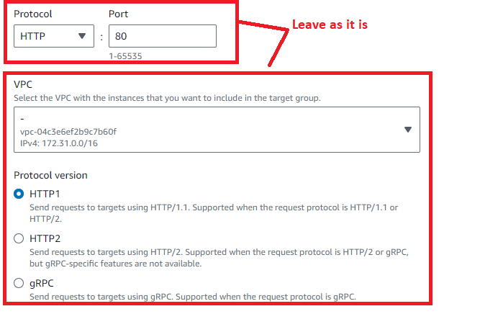

**Step 6: Leave** the **other settings by default** & **click** onthe **“Next”.**

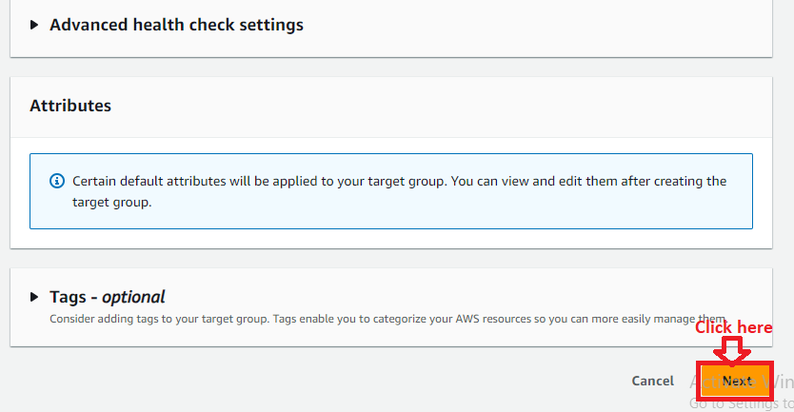

**Step 7: Select** the **Instance Id** & **All** the **instance** will be **automatically selected. Click** onthe **“Include as pending below”.**

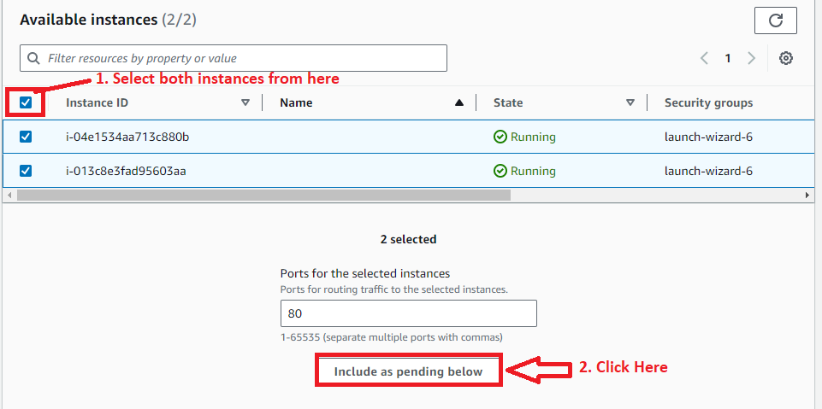

**Step 8: The instances** will be **added** inthe **“Review Targets”** & **click** onthe **“Create target groups”.**

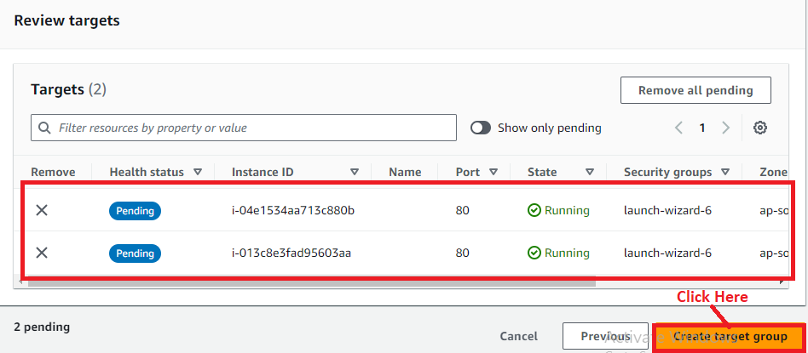

**Step 9: The “Target group”** will be **successfully created.**

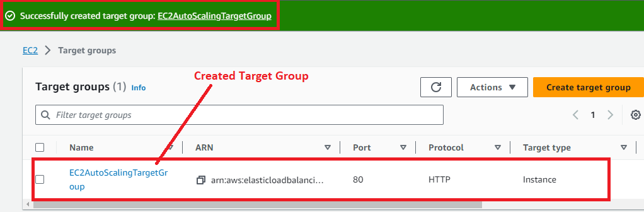

**C. Create an Application Load Balancer for EC2 Auto Scaling Group**

**Step 1: Click** on the **“Load Balancers”.**

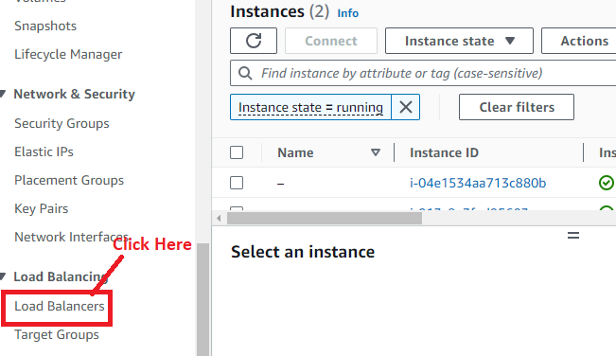

**Step 2: Click** on the **“Create load balancer”.**

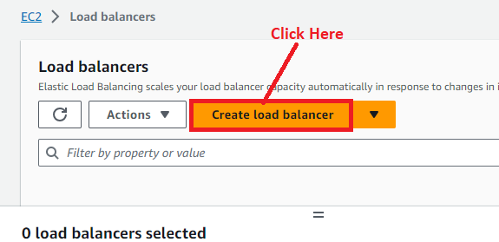

**Step 3: Click** onthe **“Create”** inthe **“Application Load Balancer”.**

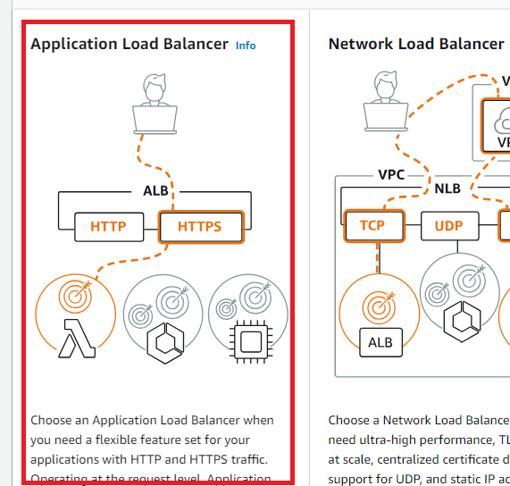

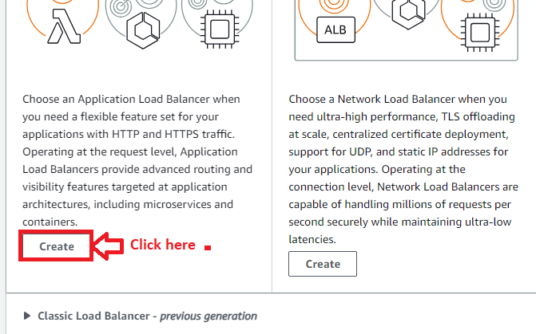

**Step 4: Choose the “Load balancer name”** as the **“EC2AppAutoLoadBalancer”** in the **“Basic Configuration”. Leave** the **“Scheme” & “IP Address type”** as **it is.**

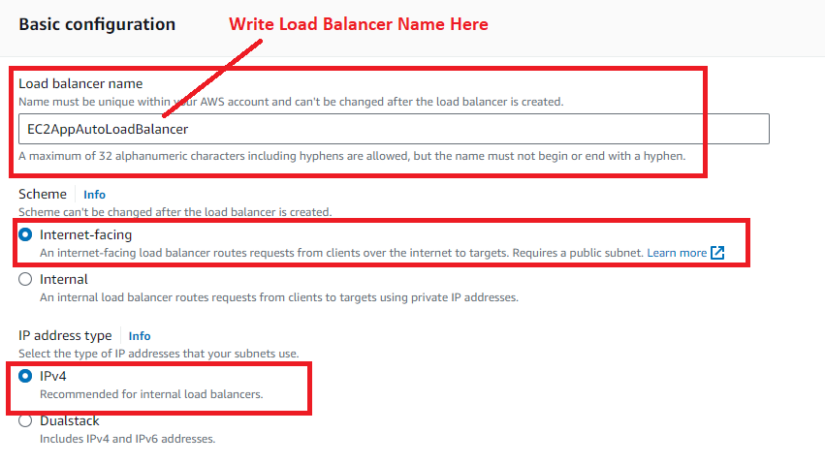

**Step 5: In** the **“Network Mapping”, choose** the **“Availability Zone”** as **“ap-south-1a” & “ap-south-1b”. Also, choose** the **subnets** in **these zones also.**

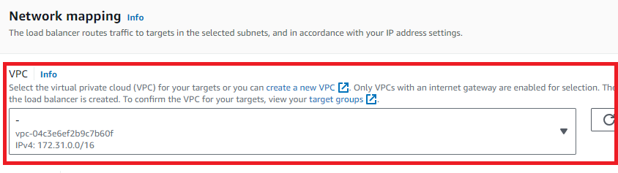

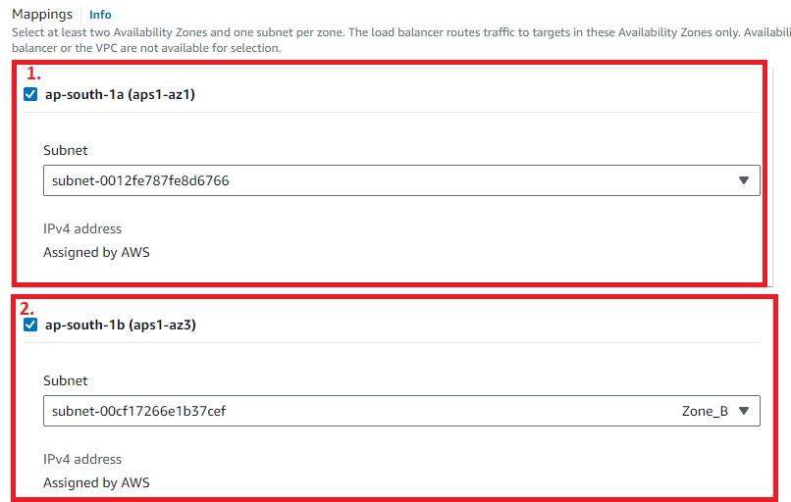

**Step 6: Leave** the **“Security groups”** as **by default.**

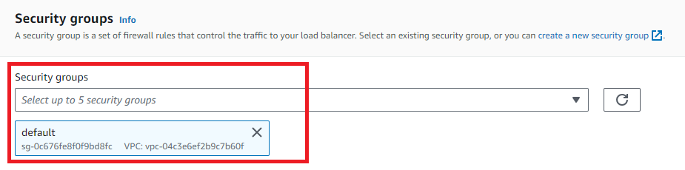

**Step 7: In** the **“Default Action”, choose** the **“Target Group”** asthe **“EC2AutoScalingtargetGroup”.**

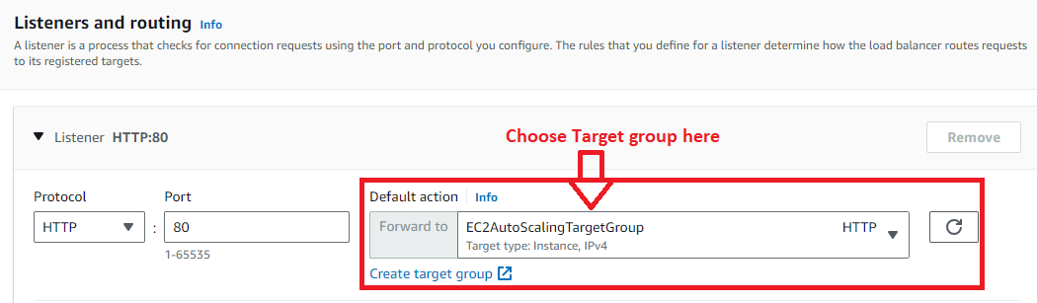

**Step 8: Leave** the **other settings** as **it is & click** onthe **“Create load balancer”.**

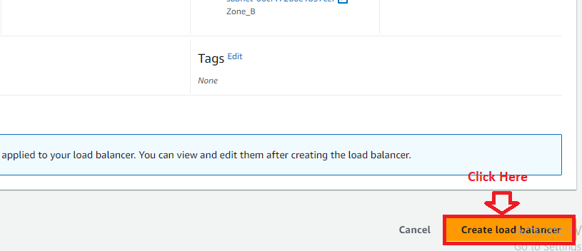

**Step 9: A load balancer** will be **successfully created. Click** on the **“View load balancer”.**

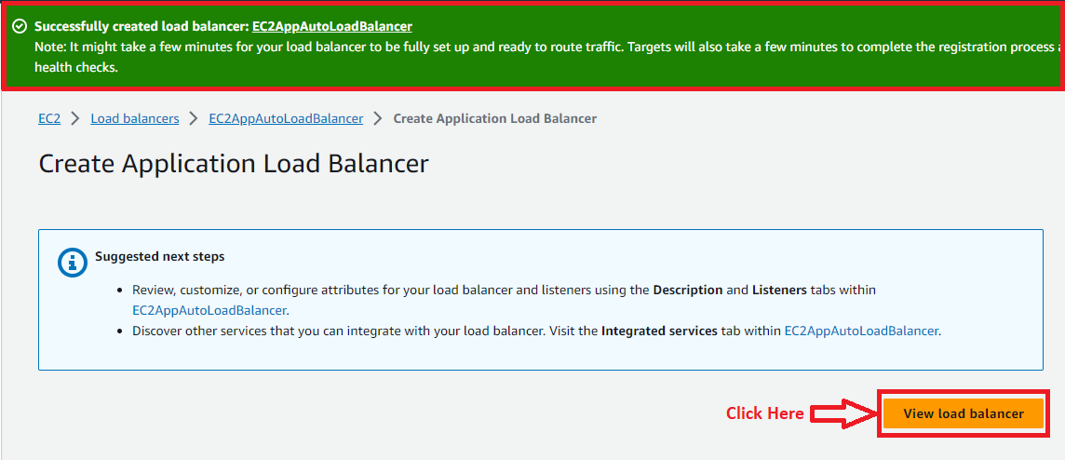

**Step 10: Click** on the **“Load Balancer Hyperlink (EC2AppAutoLoadBalancer)”.**

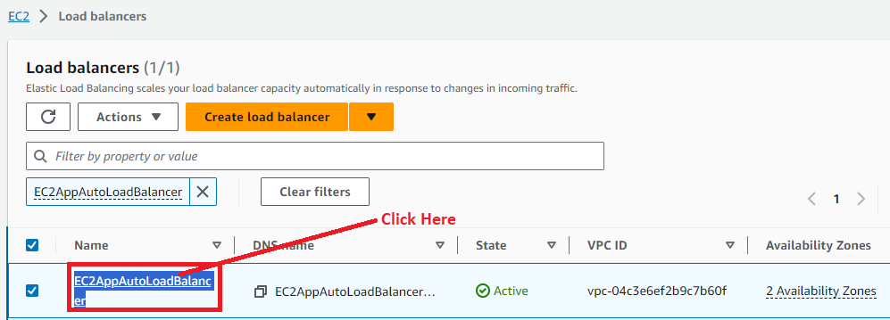

**Step 11: Copy** the **“DNS Name” Record** by **clicking** onthe **given button.**

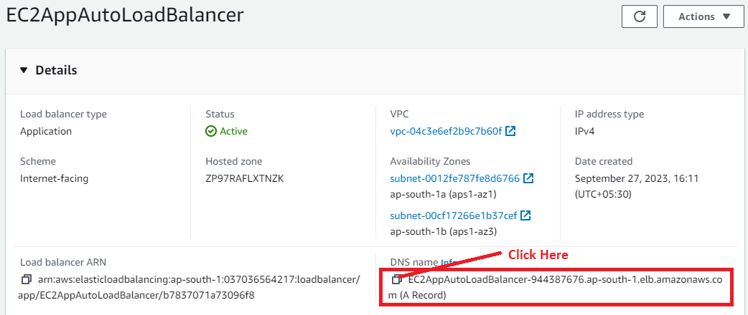

**Step 12: Paste** the **URL** in **the browser address bar** & **you** will **notice both** the **apache web server running** with **different pages** with **different private IP address included.**



**So, the load balancer** is **working fine** with **EC2 Auto Scaling Group.**

**D. Attach the Load Balancing (Target Groups) to EC2 Auto Scaling**

**Step 1: Go** to the **“Services”** section& **search** the **“EC2”** here**. Put** the **cursor** over **“EC2”** **&** **click** on the **“Dashboard”.**



**Step 2: Scroll down** inthe **left side menu bar** & **click** onthe **“Auto Scaling Groups”.**



**Step 3: Click** on the **“MySecondAutoScalingGroup”.**



**Step 4: Scroll down** & **you** will **notice “Load Balancing”** section & **click** on the **“Edit”.**

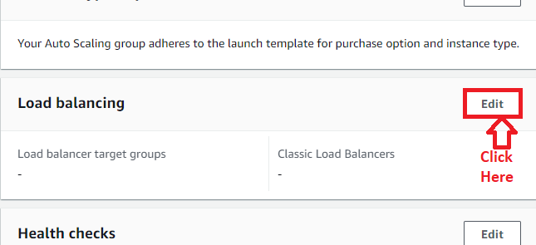

**Step 5: Choose** the **“Application, Network or Gateway Load Balancer target groups”. Select** your **“target group”** & **click** onthe **“Update”.**

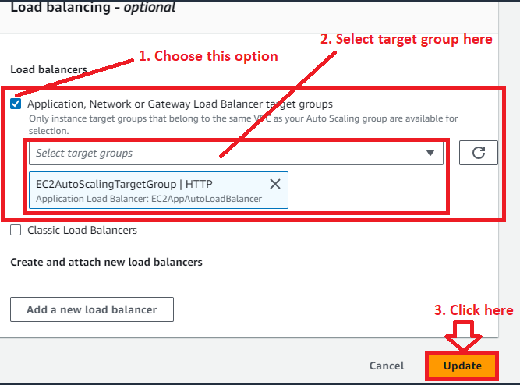

**Step 6: Your load balancing** will **be successfully attached** withthe **“EC2 Auto Scaling Group”.**

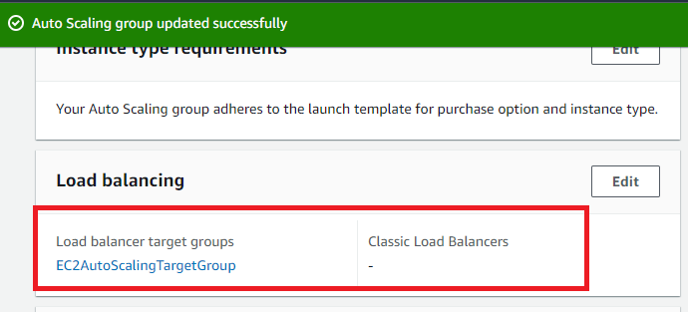

***Note: When any instance will be launched by Auto scaling group, it will automatically add to the “target group” & in “load balancer”.***

**E. Testing that Target Group Automatically Adds the Instance When we do any change in Auto Scaling Group**

**Step 1: Go** tothe **“Details”** & **click** onthe **“Edit”** in the **“Group details”.**

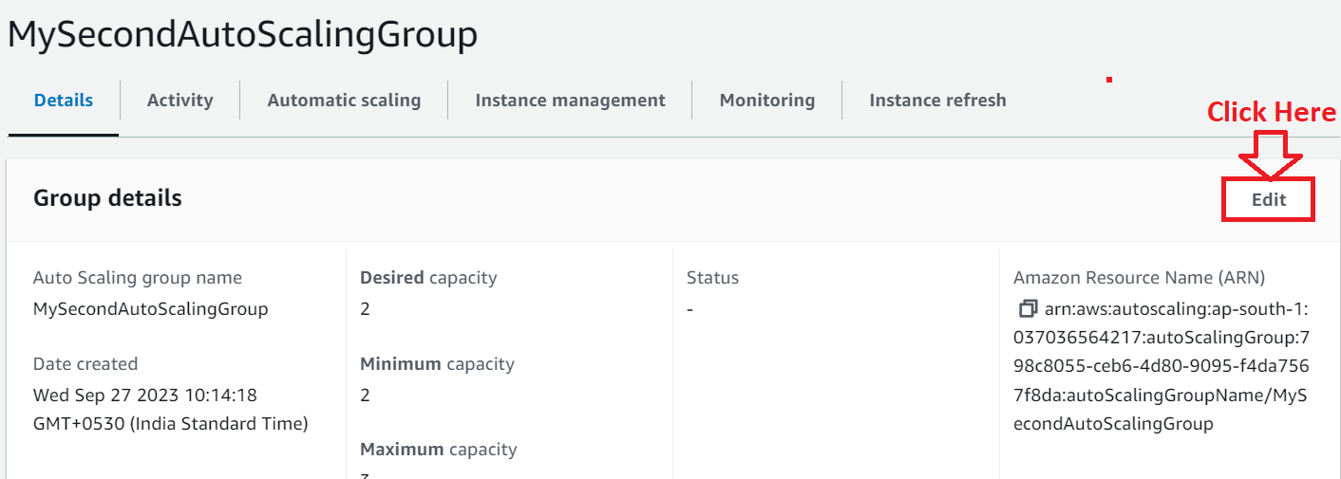

**Step 2: Now, we** will **increase** the **“desired & minimum capacity”** to **“3”** from **“2”. Click** onthe **“Update”.**

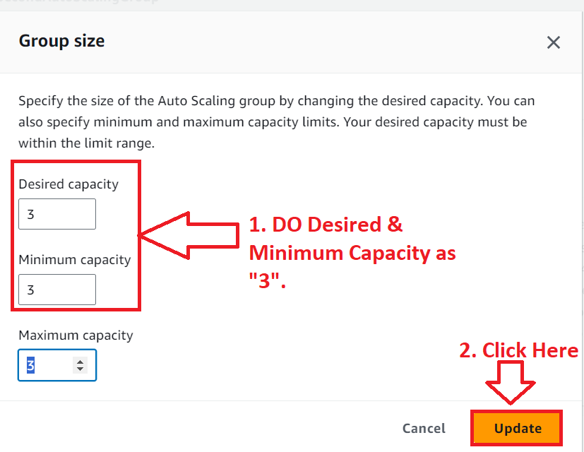

**Step 3: Now the “Status”** is **shown** asthe **“Updating capacity”.**

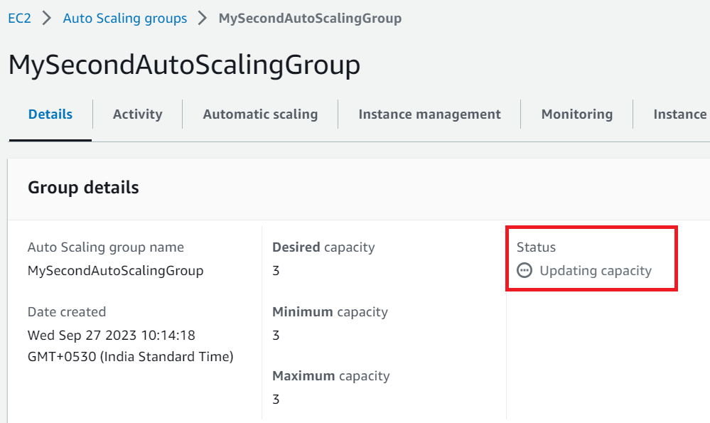

**Step 4: Go** to the **“Activity”. You** will **notice** a **message “Launching a new EC2 Instance”.**

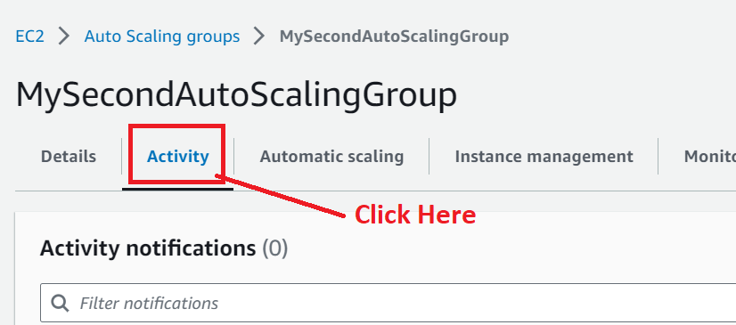

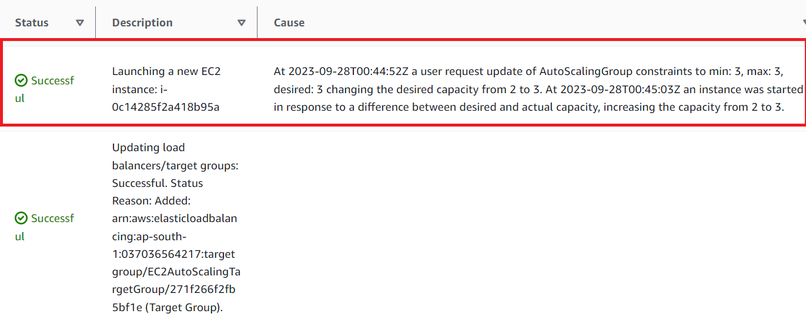

**Step 5: Now, click** on the **“EC2 Dashboard”** & **go** tothe **“Instances (running)”.**

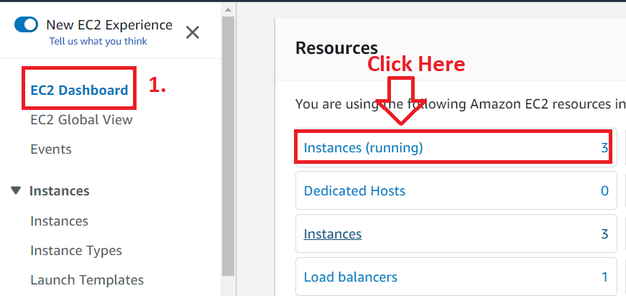

**Step 6: You** will **notice** that **now “three instances”** are **running** besides **“two”. Third Instance** is a **newly launched instance.**

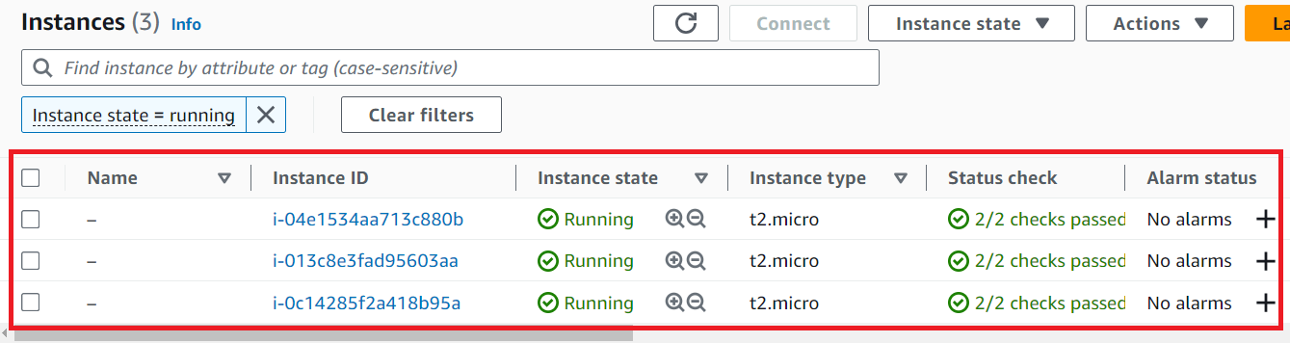

**Step 7: Go** to the **left side & scroll down** tothe **“Target Groups”. Click** on the **“Target Groups”.**

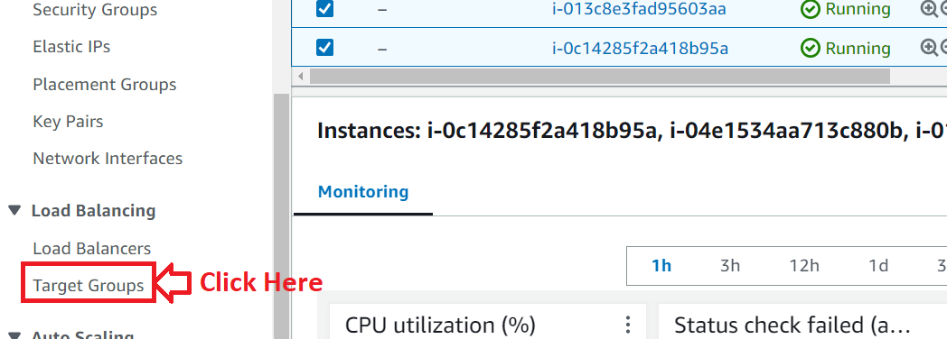

**Step 8: Click** onthe **“EC2AutoScalingTargetGroup”.**

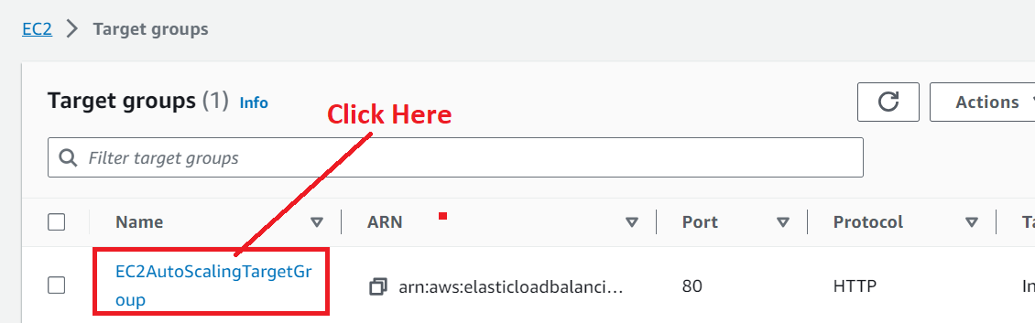

**Step 9: Scroll down & you** will **notice** the **three “Registered targets”. It** means **your third instance** has been **automatically added.**

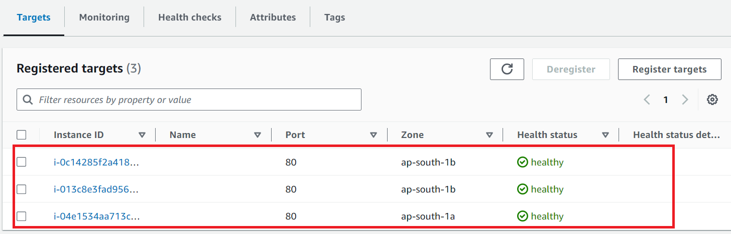

**Step 10: Now, click** onthe **“Load Balancer”** inthe **“left side bar”.**

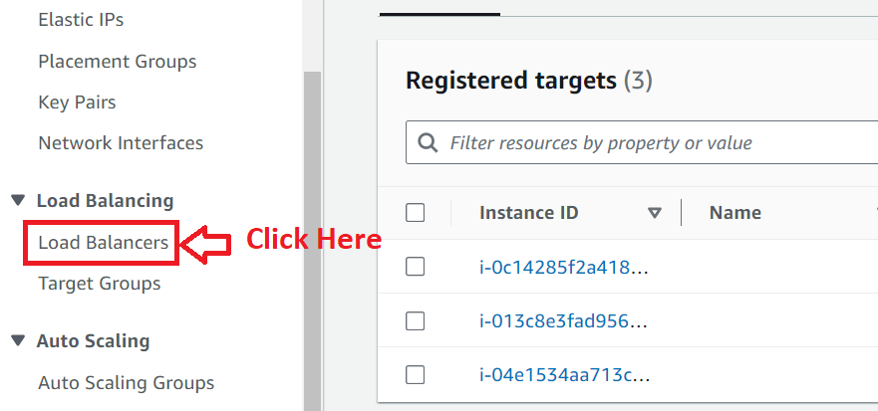

**Step 11: Click** onthe **“Load Balancer (EC2AppAutoLoadBalancer)”.**

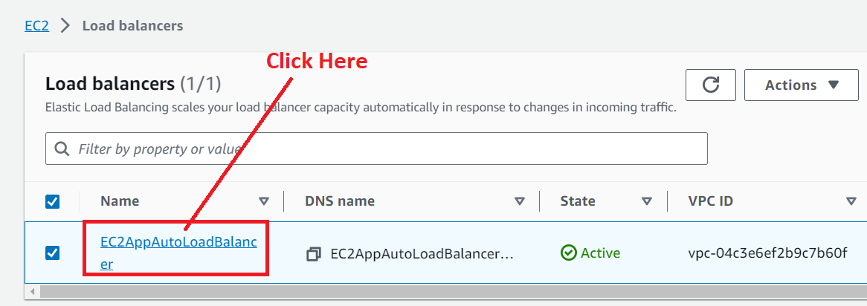

**Step 12: Copy** the **URL** fromthe **“DNS Name”.**

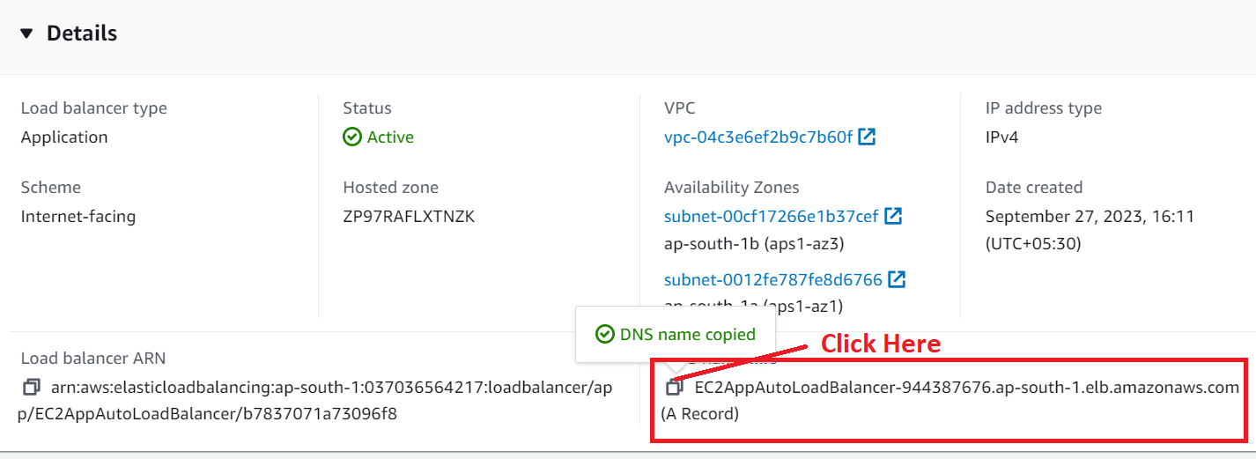

**Step 13: Paste** the **URL** inthe **separate browser address bar** & **press** the **“Enter” from** the **keyboard. You** will **notice** the **three different private IP addresses** in the **web page.**

**If** the **three different private IP addresses** will be **shown** in a **web page, this means, your load balancer** is **working fine** withthe **Automatic Scaling Groups.**



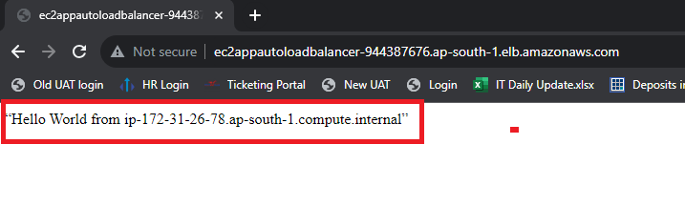

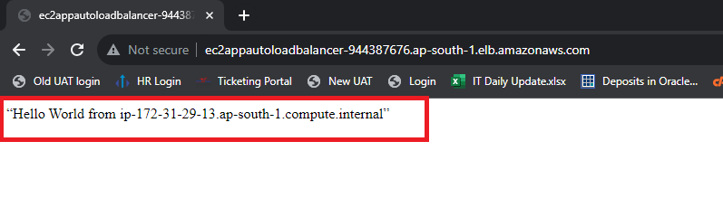

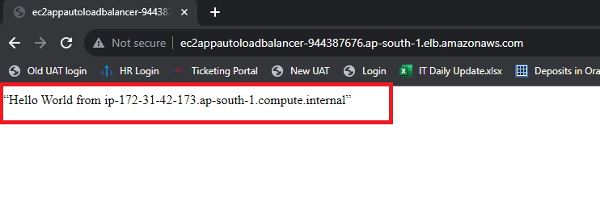

**Problem (3) Solution:** Route the traffic to the company domain.

**A. Register a Domain with AWS & It Automatically Creates Hosted Zones**

**Step 1: Go** to **the “Services”** section& **search** the **“Route 53”. Click** onthe **“Domain Names”.**

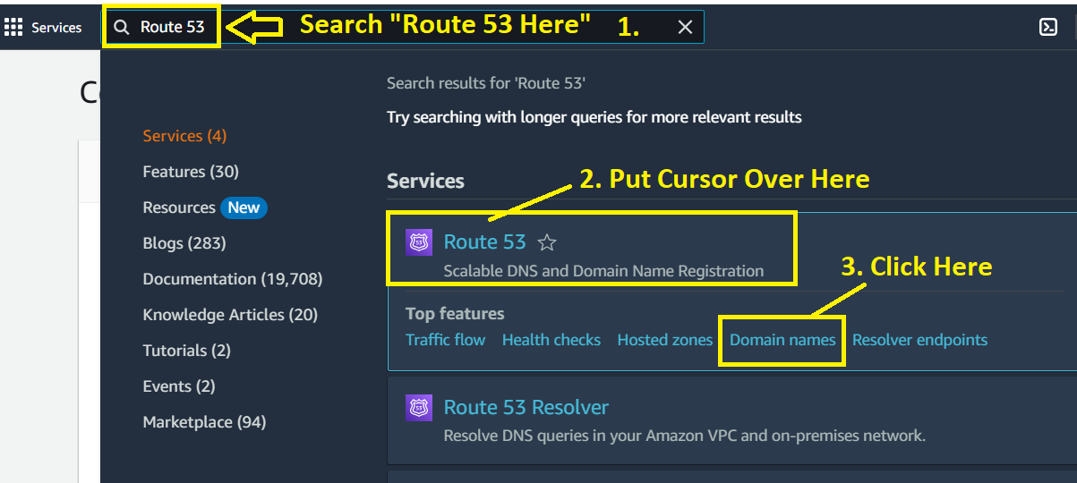

**Step 2: Click** onthe **“Register Domains”.**

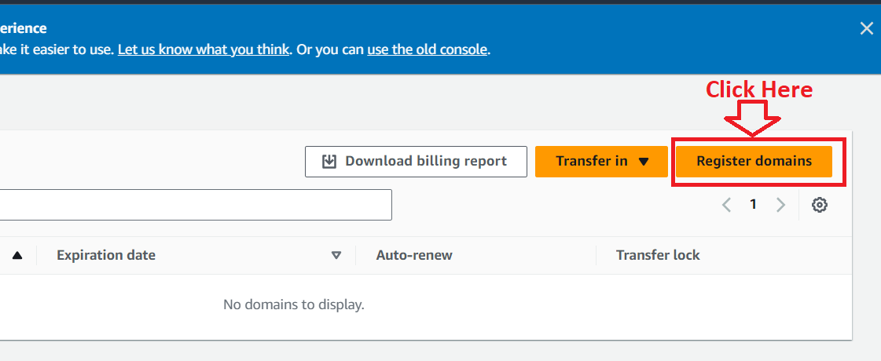

**Step 3: Search** the **domain** with **.click. They** will **charge** you **3$** only**. Put “your domain (visal.click)”** & **click** onthe **“Search”.**

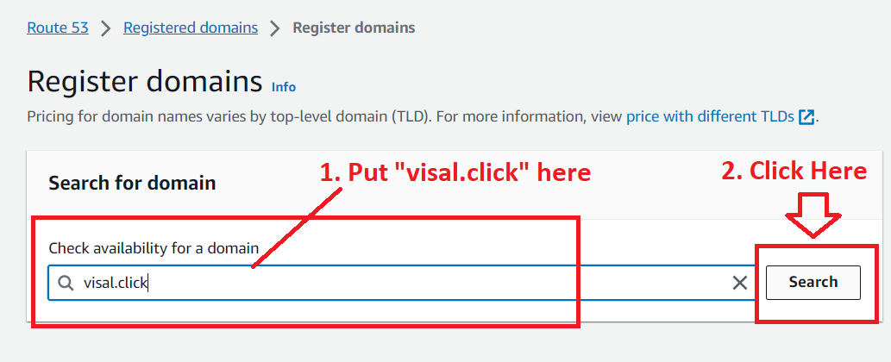

**Step 4: Click** onthe **“Select”.**

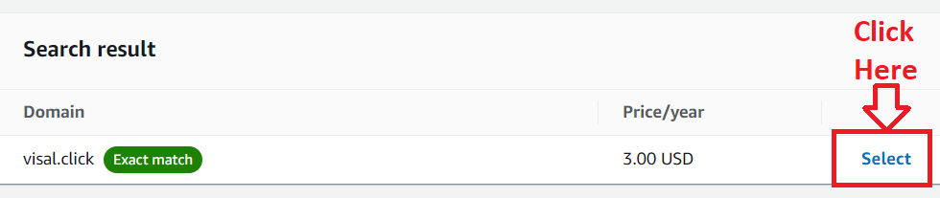

**Step 5: Click** onthe **“Proceed to Checkout”.**

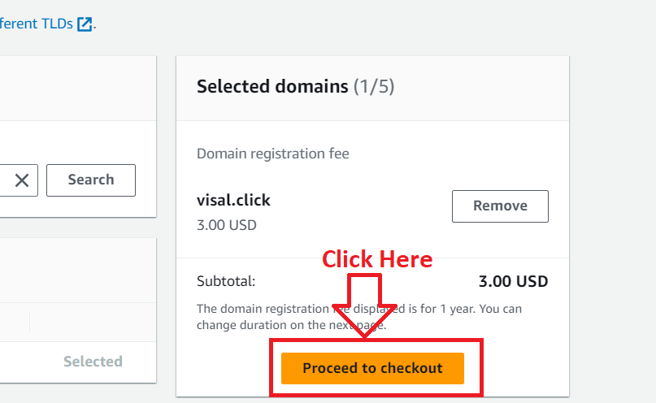

**Step 6: We** will **disable** the **“Auto Renew” here** by **deselecting** this **option. Click** onthe **“Next”.**

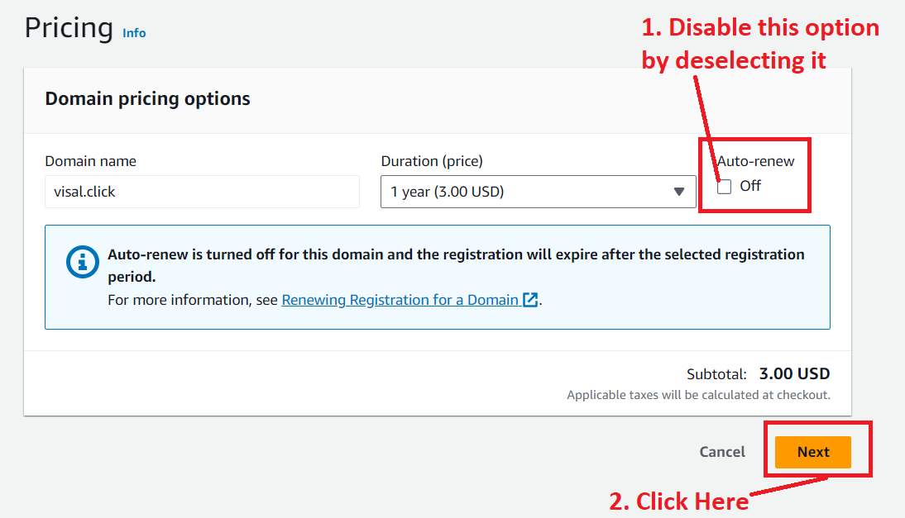

**Step 7: Put** your **contact information. I** am **putting** my **details** over **here & click** on the **“Next”. (I am not showing the information here, but after putting the details, I** will **click** on the **“Next”.)**

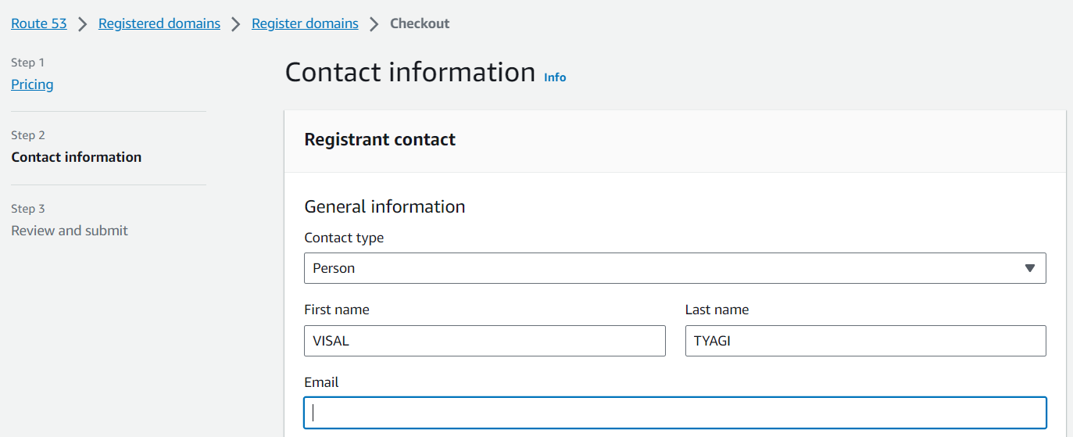

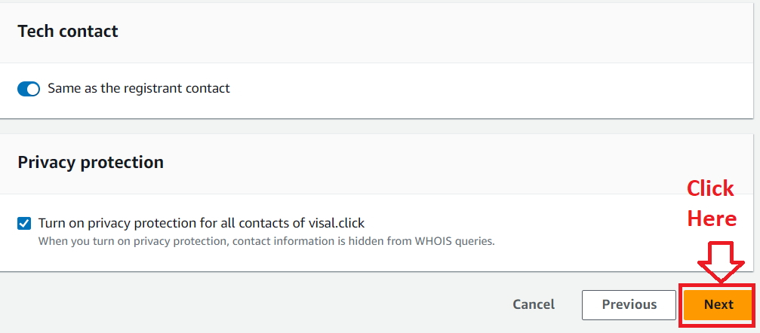

**Step 8: In** the **“Review & submit”, it** will **show** you **all** the **details. Select** the **“Terms & Conditions”** & **click** onthe **“Submit”.**

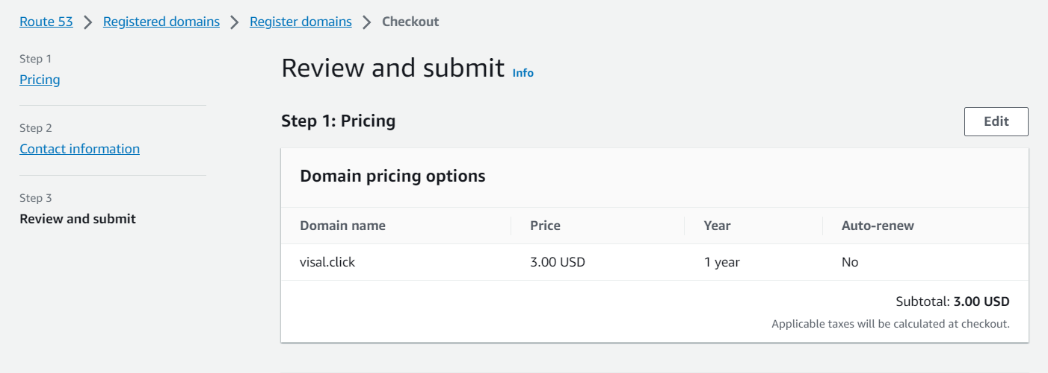

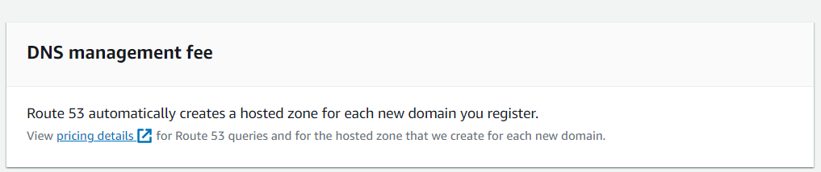

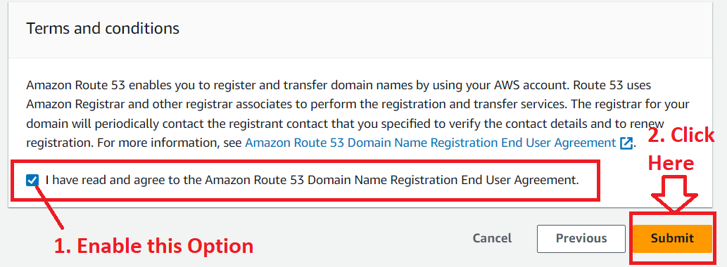

**Step 9: It** will **show** that **domain registration request** is inthe **“progress”** & **click** onthe **“Check Status”.**

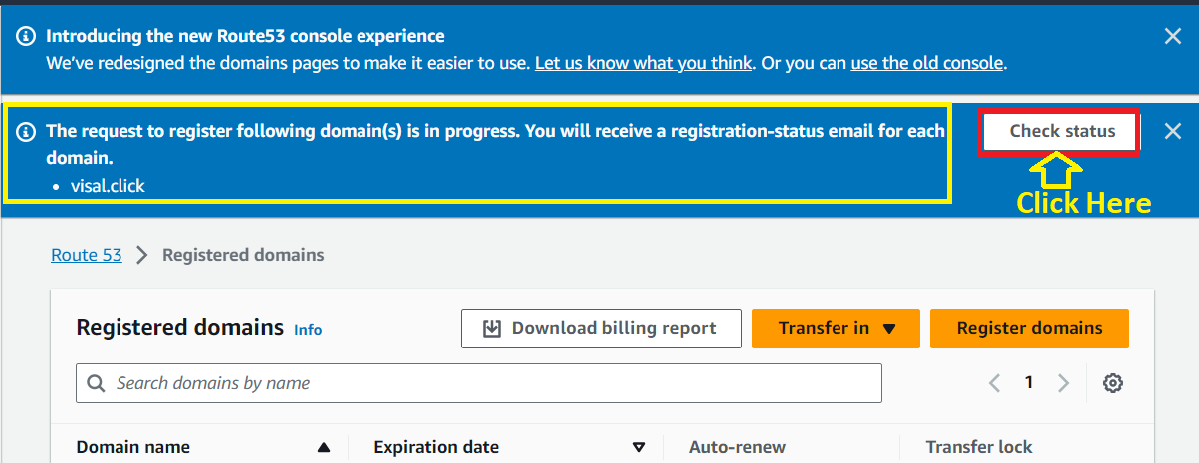

**Step 10: In** the **“Requests”, it** is **showing** the **“Action Required”** inthe **“Status”.**

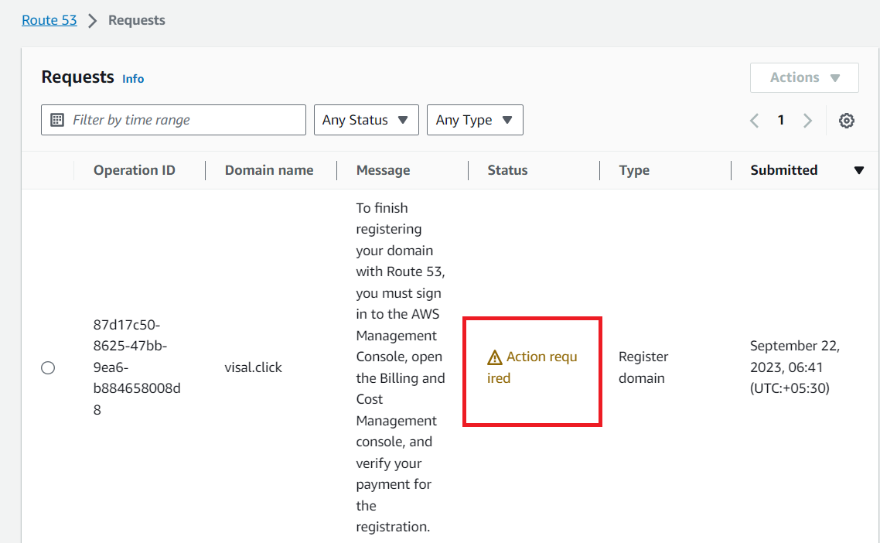

**Step 11: Select** the **Operation Id. Go** to the **“Actions>Verify payment”.**

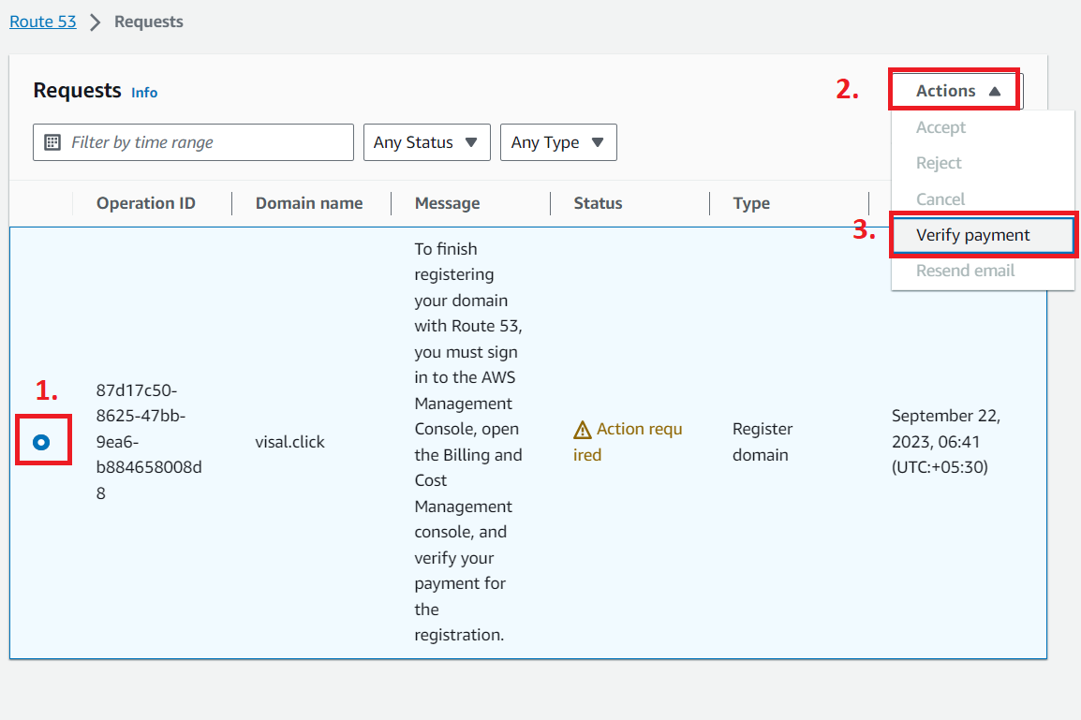

**Step 12: Click** on the **“Complete Payment”.**

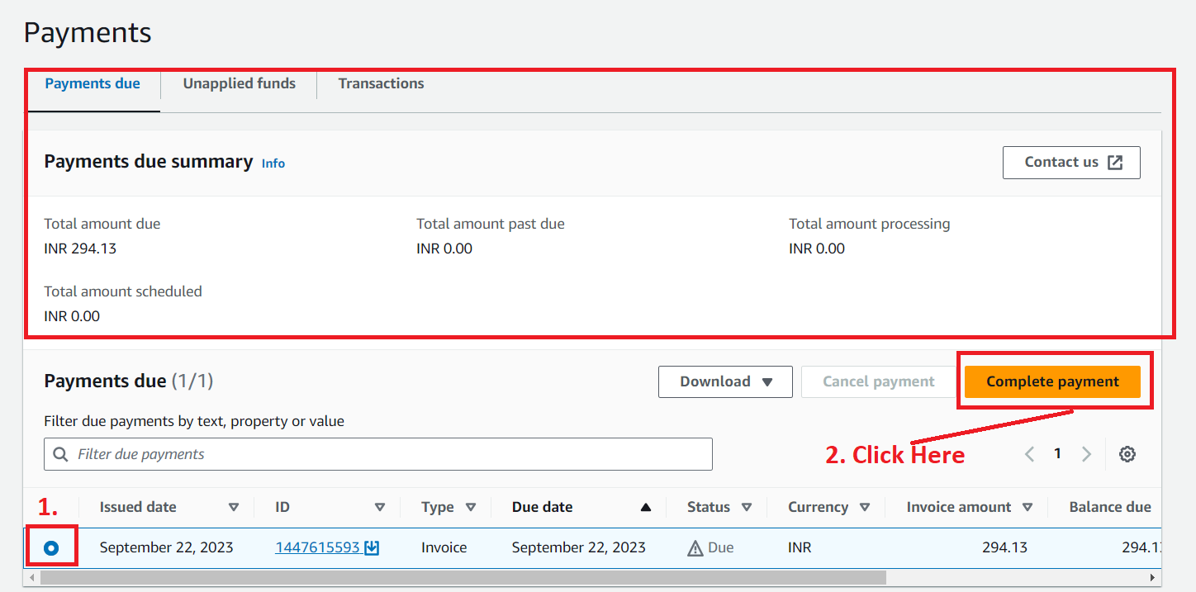

**Step 13: We** will **use the “Debit card”** here. **Click** onthe **“Use credit/debit card”.**

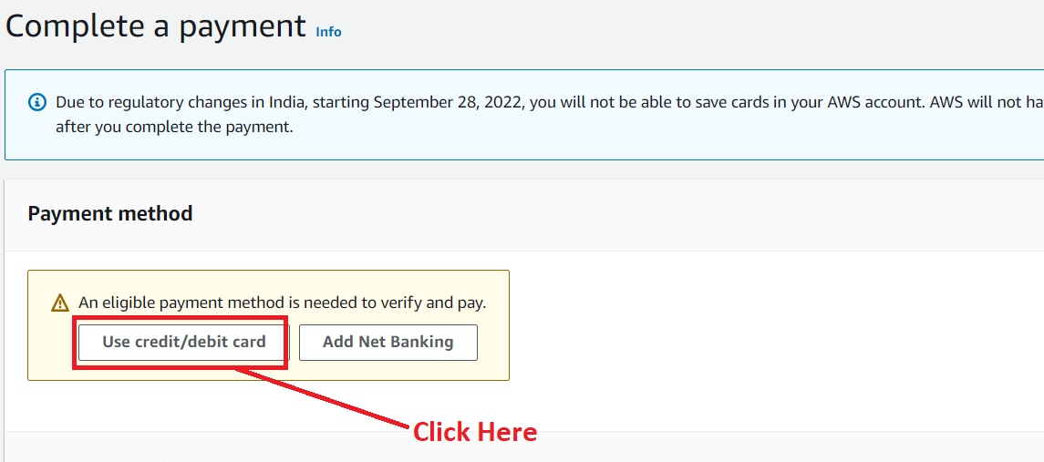

**Step 14: Add** your **card & contact address information** over **here & click** onthe **“Next”.**

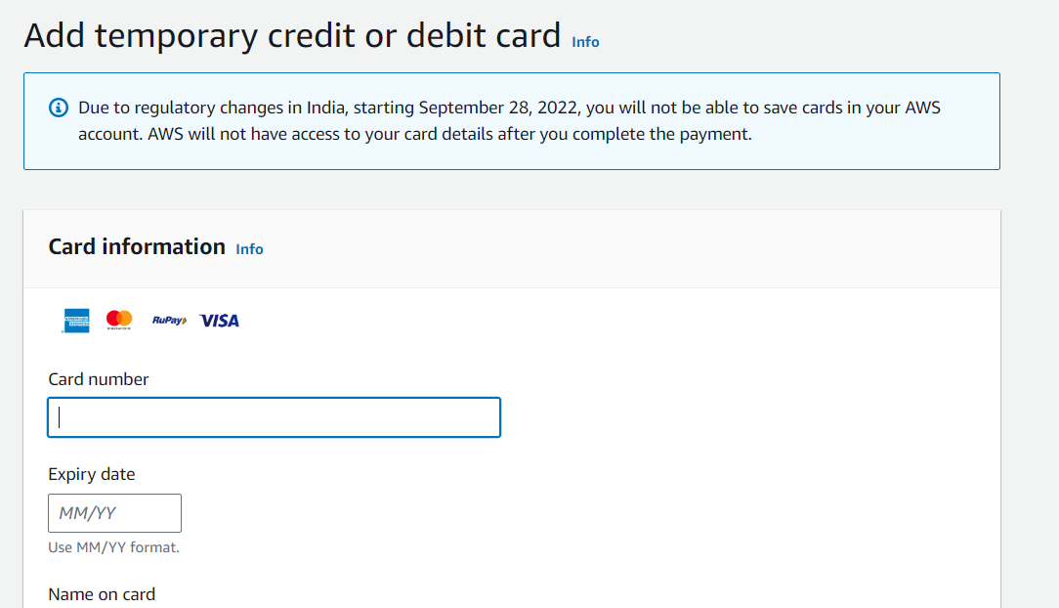

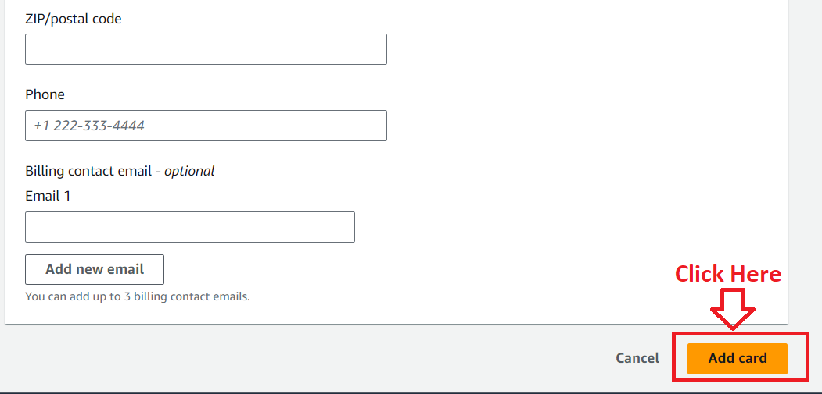

**Step 15: Now, the card** has been **successfully added. Enter** your **CVC here & click** on the **“Verify and Pay”.**

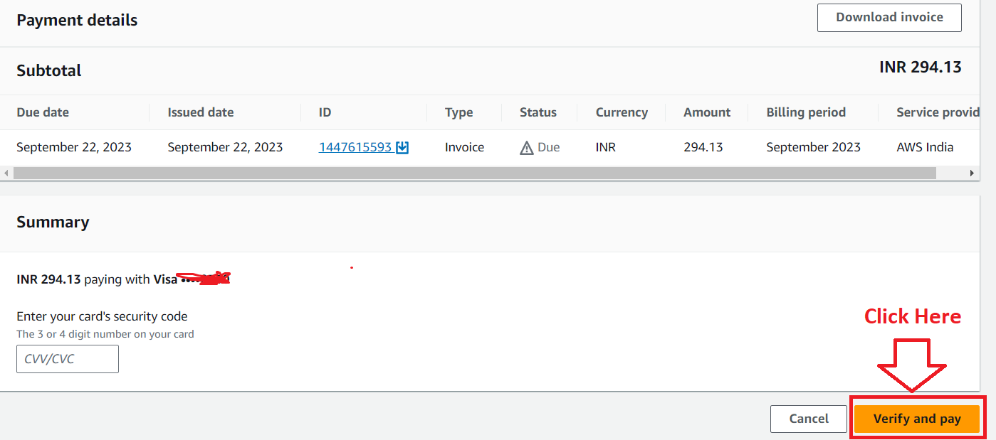

**Step 16: Click** on the **“Proceed”.**

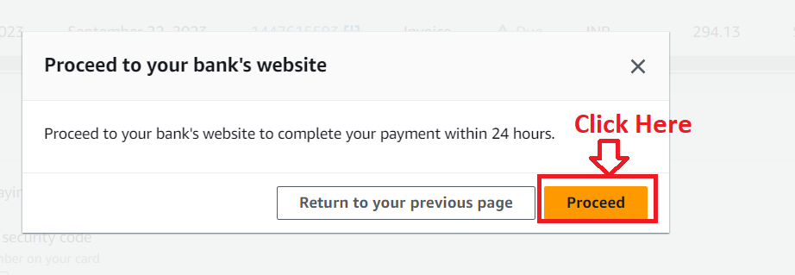

**Step 17: After completing** the **payment, A message “Successfully complete your payment”** will be **shown here.**

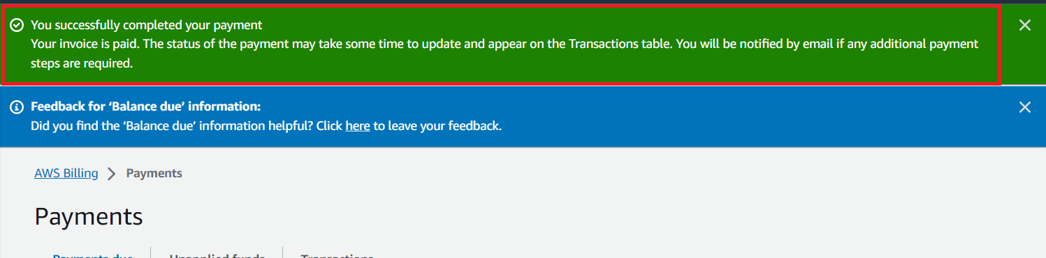

**Step 18: It** will **take some time** to **update** the **“payment status”. (Approx 1-5 minutes).**

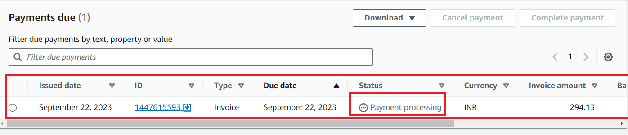

**Step 19: Go** to the **“Transactions” & your payment information** will be **shown like this;**

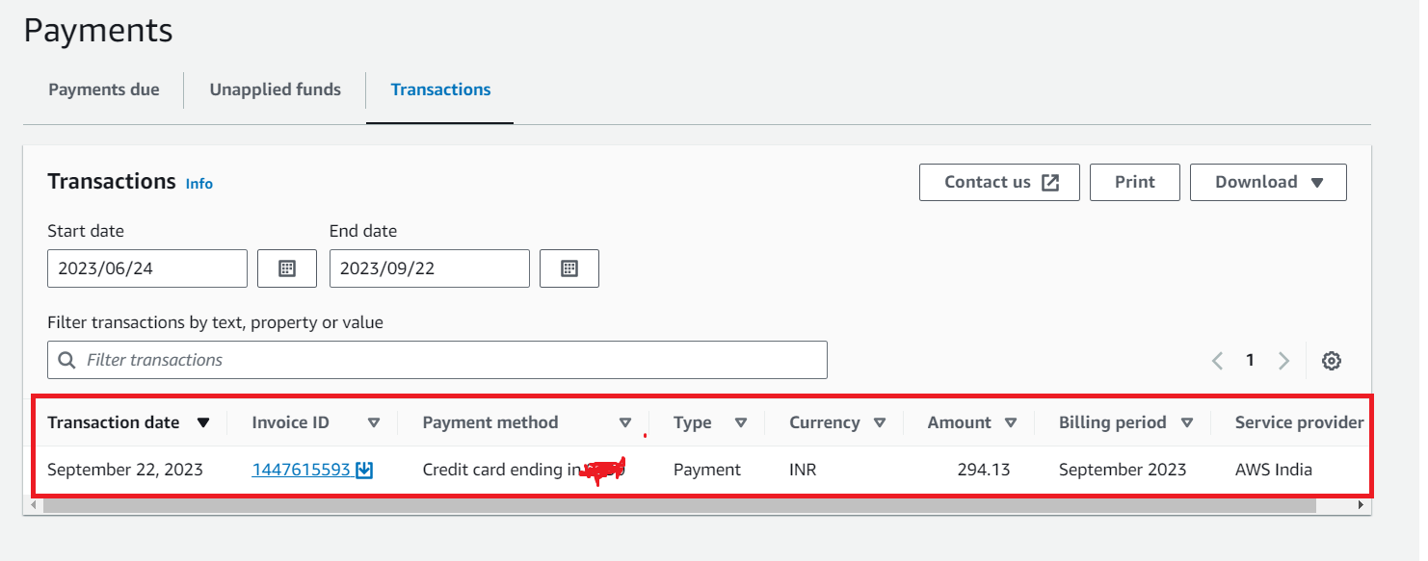

**Step 20: Search** the **“Route 53” Again** inthe **“Services” section** & **click** onthe **“Route 53”.**

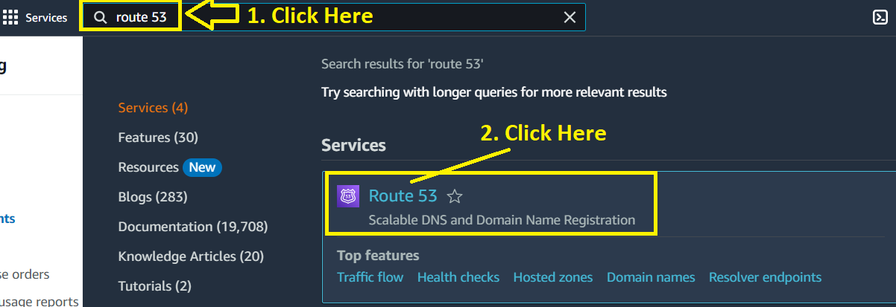

**Step 21: In** the **“Route 53 Dashboard”, the “Status”** is **shown** asthe **“Domain registration in progress”** underthe **“Notifications”** section**.**

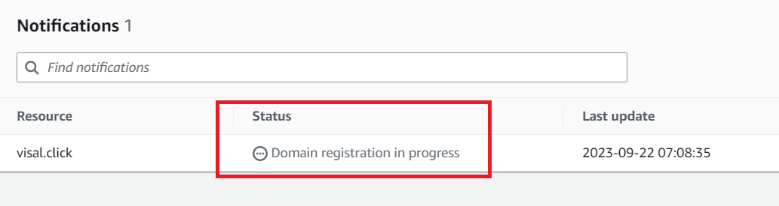

**Step 22: Amazon Web Services** will **send you** a **mail** to **confirm** the **email address** for your **domain (visal.click). Open** this **email** by **clicking** on **it.**

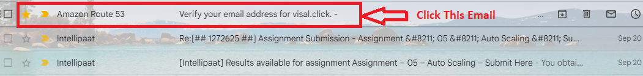

**Step 23: Click** on **the given link** in **the “Gmail”** for **verifying** the **email address.**

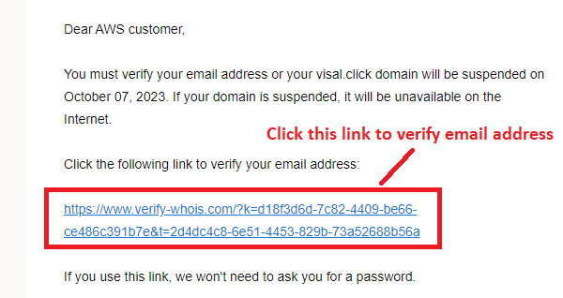

**Step 24: A “Thank You” Message** for **Email Id Confirmation** will be **shown** in the **another tab.**

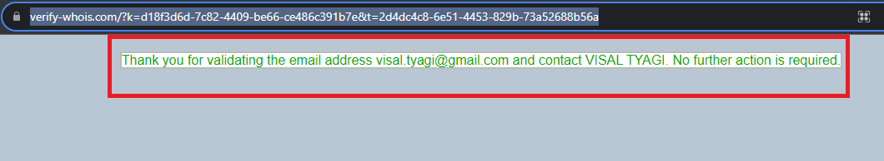

**Step 25: Again, go** to **your “Gmail”** & **the email Address Verified** will be **triggered** to **your inbox like this;**

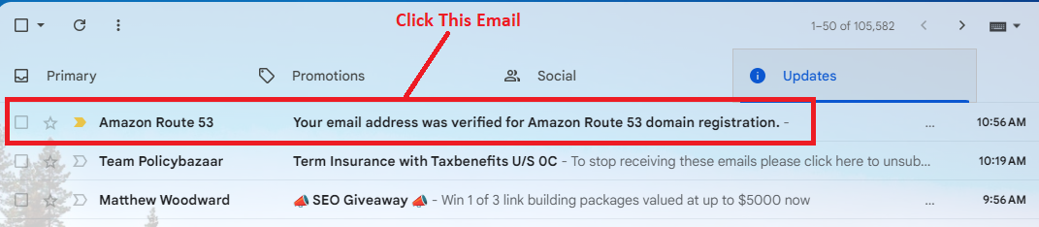

**Step 26: Click** on **this email** & **your email address** will be **successfully confirmed message** will be **shown here.**

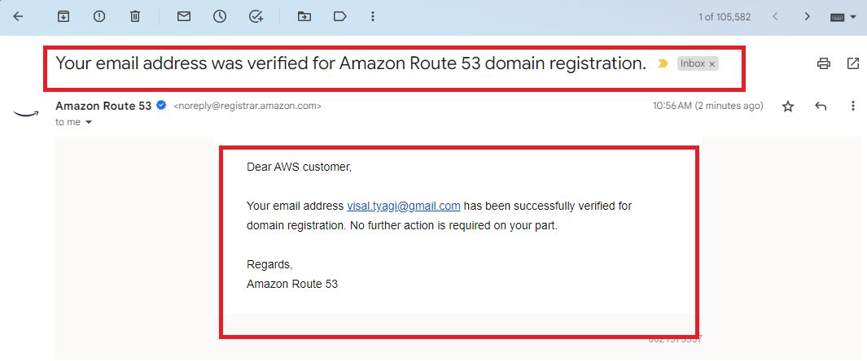

**Step 27: After sometime, you** will **get** an **email** from **AWS** that your **domain** is **successfully registered** & **set up** your **DNS records** now.

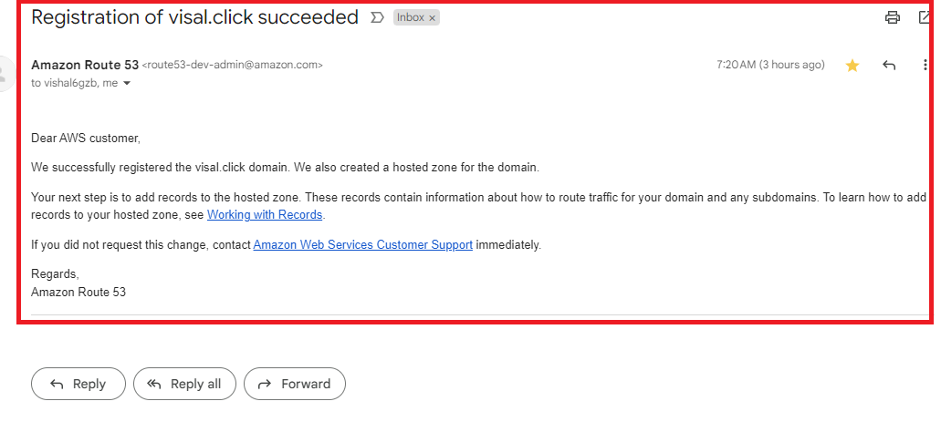

**Step 28: Now, go** tothe **“Amazon Route 53” dashboard** & In the **“Notifications”** section, the **“Status”** is **shown** as the **“Domain Registration Successful”.**

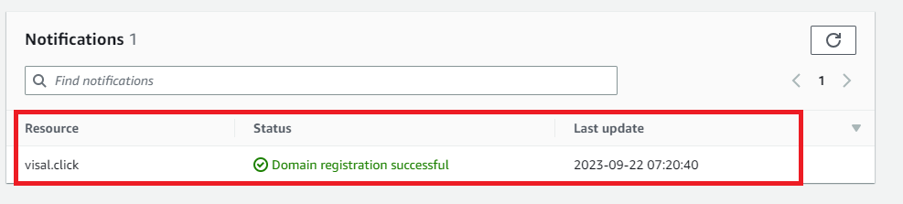

**Step 29: In the “Dashboard”, you** will see **“1 Domain is Registered** & **1 Hosted Zone Created”. Here, we don’t need** to **create** the **hosted zone manually. AWS Automatically creates** afterthe **domain registration successful.**

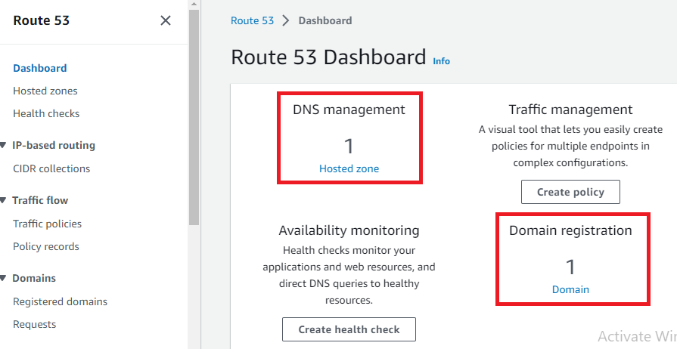

**Step 30: Go** tothe **“Hosted Zones”.**

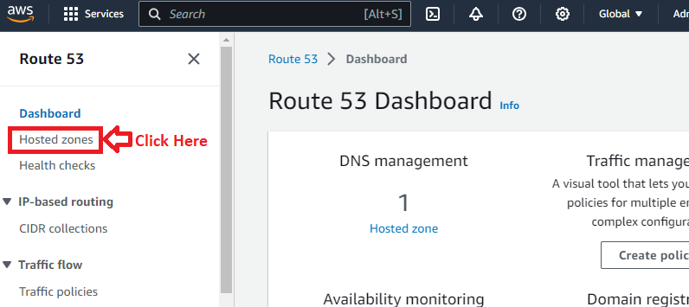

**Step 31: Your Automatically created hosted zone** will be **shown** & **you** can **view** your **DNS records details** here**.**

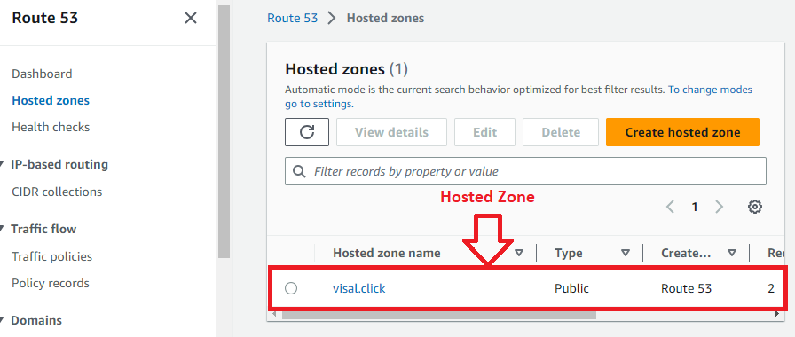

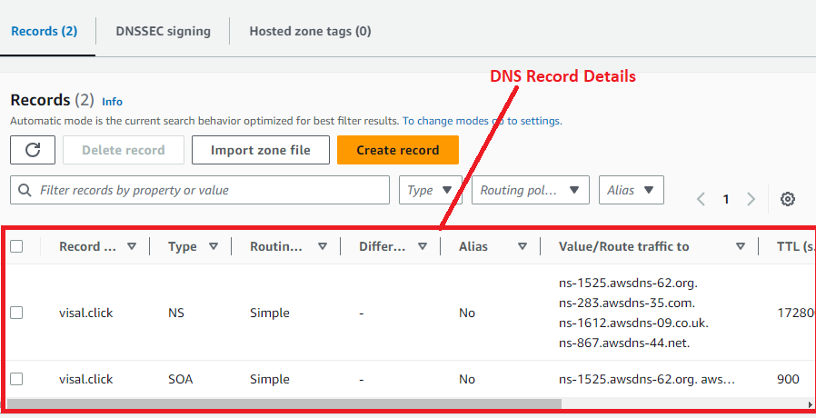

***Note: You can register a domain with other domain name providers like GoDaddy, Namecheap, Bigrock etc. But for domain outside, you have to create hosted zone manually & paste the DNS of AWS in that hosting provider DNS Configuration.***

**B. Route the Traffic to the Company Domain**

***Note: Here, we assume “visal.click” as our company domain. Now, we will route the “Automatic Scaling Load Balancer Traffic” to our domain (visal.click).***

**Step 1: Click** onthe **“Create record”.**

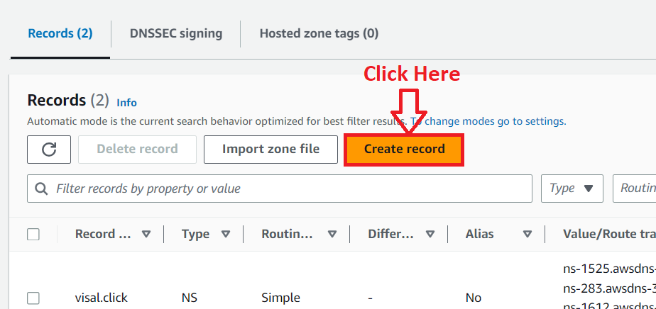

**Step 2: Enable** the **“Alias” option** by **clicking.**

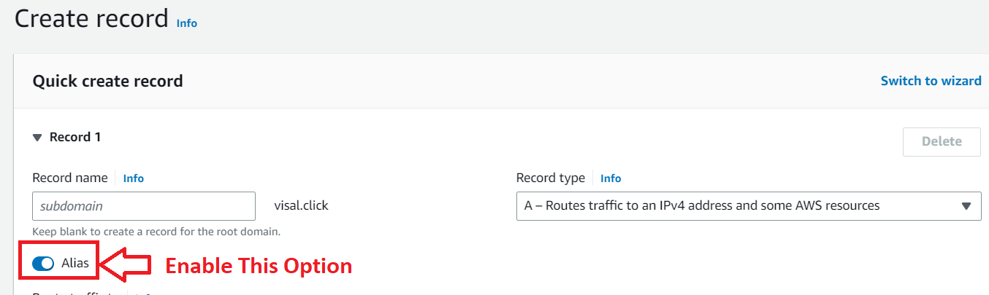

**Step 3: In** the **“Route traffic to”, choose** the **following options** here:

**Choose endpoint –** *“Alias to Application and classic load balancer”*

**Choose Region –** *“Asia Pacific (Mumbai)”*

**Choose load balancer –** “*Choose your load balancer URL here (*[*http://ec2appautoloadbalancer-944387676.ap-south-1.elb.amazonaws.com/*](http://ec2appautoloadbalancer-944387676.ap-south-1.elb.amazonaws.com/)*)”*

**Routing Policy –** *“Simple Routing”*

**Click** on the **“Create records”.**

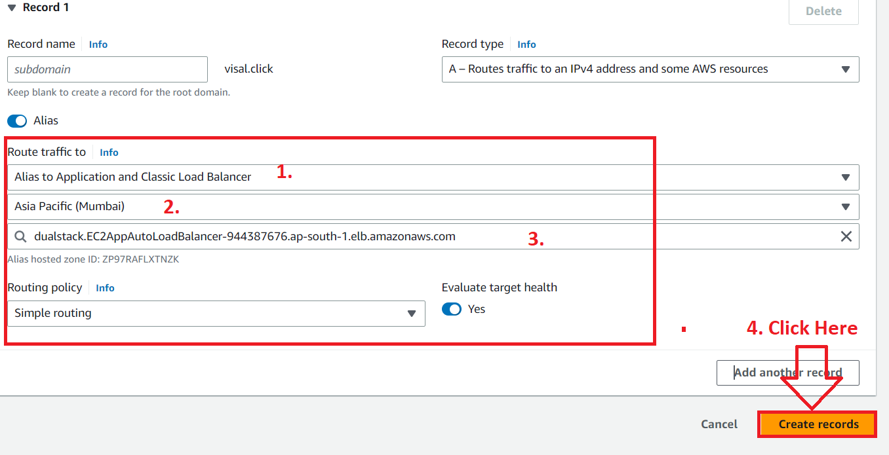

**Step 4: The DNS records** will be **successfully added. And click** onthe **“View Status”. It** takes **60 seconds** to **route** the **traffic** tothe **domain (visal.click).**

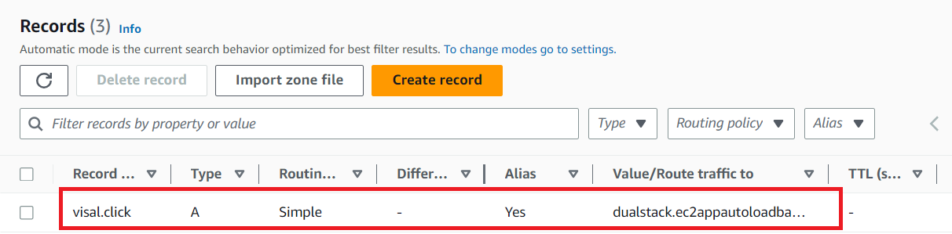

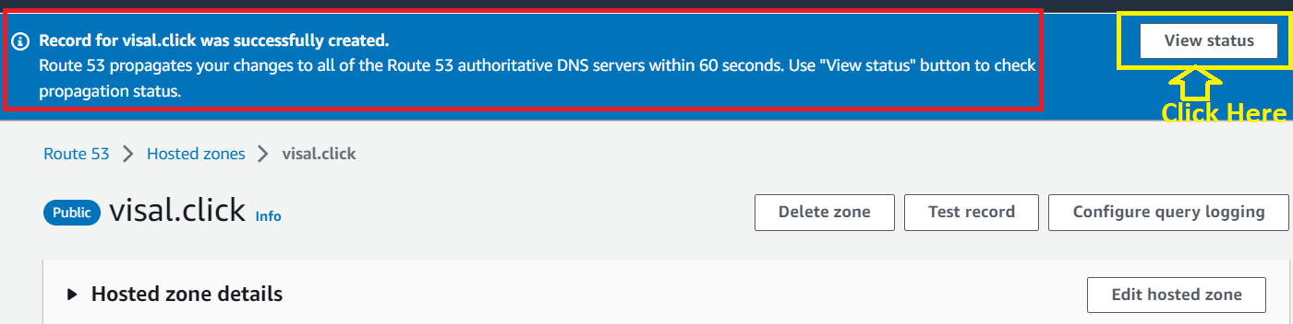

**Step 5: The status** will be **shown** asthe **“INSYNC”. It means** your **load balancer traffic** is **successfully routed** to the **company domain (visal.click). Initially, it** will be **in** the **“Pending State”.**

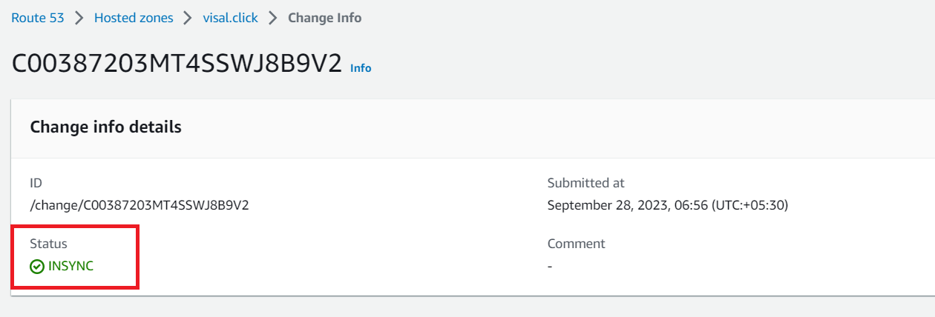

**Step 6: Now, go** to the **browser** and **type** the **domain name (visal.click)** in the **browser address bar** & **press** the **“enter” many times** from the **keyboard** for **refreshing** the **web page. You** will **notice** that **the load balancer different web pages** will be **shown** with the **different private IP addresses.**



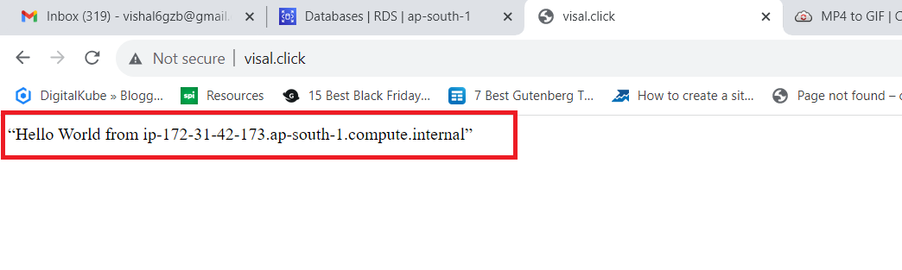

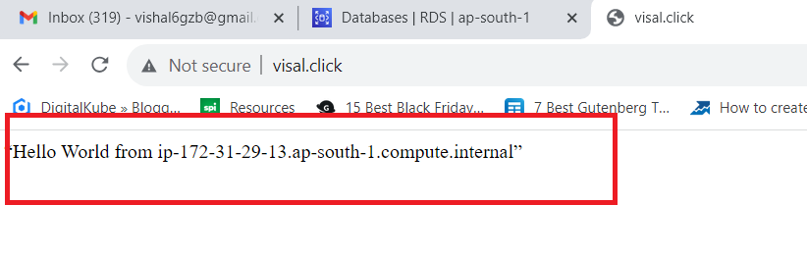

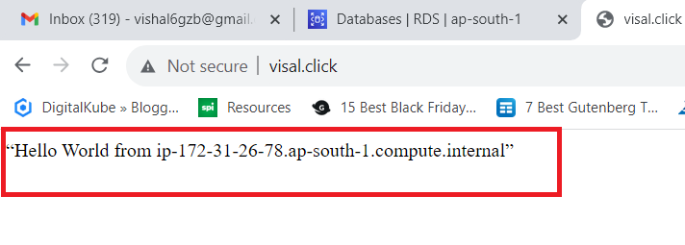

***So this is the complete Assignment of ELB, ASG & Route 53 Assignment Solution.***